2nd Revision of Online Appendix

**Waiting for kin: a longitudinal study of family reunification and refugee mental health in Germany**

Lea-Maria Löbelabc, Jannes Jacobsena

a German Institute for Economic Research (DIW) Berlin, Socio Economic Panel (SOEP), Mohrenstr. 58, 10117 Berlin, Germany

b International Labour Organisation, Karlplatz 7, 10117 Berlin, Germany

c Berlin Graduate School of Social Sciences, Humboldt University, Luisenstr. 56, 10117 Berlin, Germany

Corresponding author: Lea-Maria Löbel, loebel@ilo.org, International Labour Organisation, Karlplatz 7, 10117 Berlin, Germany

**Table of Content**

1. Legal context 3

1.1 Treaties 3

1.2 Definition of the family 3

1.3 Legal definitions in the German context 3

2. Descriptive statistics continued 5

3. Gendered regression analysis continued 9

4. Robustness checks 12

4.1 Additional analysis using share of family members remaining in the country of origin as independent variable 12

4.2 Checking for self-selection into family reunification 12

5. References 15

# **Legal context**

## **Treaties**

Family unity as a human right has first been laid down in Article 16 of the Universal Declaration of Human Rights in 1948. Since then it has been recognized in other legal instruments. Derived from this very clear assertion of the right to family unity, the 1951 Convention Relating to the Status of Refugees equally confirms family unity for refugees. A list of other treaties naming the right to family unity includes the European Convention for the Protection of Human Rights and Fundamental Freedoms 1950 (Art. 8), the European Social Charter 1961 (Art. 16), the International Covenant on Civil and Political Rights 1966 (Art. 17 and 23), and the International Covenant on Economic, Social and Cultural Rights 1966 (Art.10). Other treaties citing family unity are the American Convention on Human Rights 1969 (Article 17), Additional Protocol 1 of 1977 to the Fourth Geneva Convention Relative to the Protection of Civilian Persons in Times of War 1949 (Article 74), the African Charter on Human and Peoples’ Rights 1981 (Article 18), the Convention on the Rights of the Child 1989 (Articles 9, 10, and 22), and the African Charter on the Rights and Welfare of the Child 1990 (Articles XXIII and XXV).

## **Definition of the family**

Despite its clarity on family unity, international law is missing a universal definition of the term “family”. The increasing body of academic work and many legal rulings however point to the definition of a family as the “nuclear” family, meaning spouses and their (minor) children.

## **Legal definitions in the German context**

Germany is signatory to all conventions listed above, also the 1951 Geneva Convention. Generally, when asylum seekers[1] arrive in Germany, there are four potential outcomes of their asylum application and only the first and second listed residence titles are linked to the right to family unity explicitly by means of the law.[2]:

1. Recognition as a refugee (3-year residence permit)

The first source of legal protection from political persecution is Art.16a of the German Basic Law (*Grundgesetz*). Only a minority of refugees in Germany receives protection by means of this title since most refugees move to Germany via other European countries in which they could have equally claimed asylum. Instead, many refugees hold a title in line with the Geneva Refugee Convention and Art.60 (1) of the Act on Residence, Economic Activity and Integration of Foreigners in the Federal Territory (*AufenthG*). These first two titles are directly linked with the German Basic Law and the Geneva Convention, hence with the state obligation to reunite families.

1. Subsidiary protection (1-year residence permit)

A less protective residence status specifically designed for refugees in Germany is subsidiary protection provided by Art 60 (2-4) of the *AufenthG.* It is granted in cases of torture, civil war and other inhumane practices carried out in the country of origin. This title has been implemented in order to provide a safe harbor for those who, legally speaking, do not fall under the Geneva Convention or the German *Grundgesetz*, but need protection, nevertheless. The title grants a one-year residence permit (compared to a three-year residence permit for refugees).

1. Ban of deportation (no residence permit)

An even less protective residence status compared to the Geneva Convention is the ban of deportation (Art. 60 (5) *AufenthG*). Legally speaking, a ban of deportation does not constitute a residence permit but only avoids deportation due to medical conditions or administrative issues (e.g. invalid passport). The ban is revoked as soon as the reason for the ban disappears.

1. Deportation

In the event that the asylum claim is rejected, asylum seekers are deported within few weeks.

The family reunification procedures for the first two titles and hence groups of refugees are enshrined in the German *Aufenthaltsgesetz (Residence Act)*. Primarily, the *AufenthG* regulates family reunification in Germany in Art.27 ff. in cases where refugees have a valid passport, sufficient housing space and secure their own livelihoods. The second means to achieve family unity is the so called “privileged family reunification” via Art. 29(2) *AufenthG*. In these cases, an applicant must not prove financial independence. Nonetheless, such request for family unity only applies within three months after having received a residence permit.

Particularly refugees with subsidiary protection fall within a specific regime of family reunification laws in Germany. From 2016 onwards, family reunification for this group was suspended for two years, and has been limited for 1000 individuals per month since 2018 (Deutscher Bundestag, 2018b, 2018a, 2018c).

# **Descriptive statistics continued**

Table A1: Descriptive statistics of dependent and independent variables of interest per gender – Mean, standard error in parentheses

|  |  |  |  |
| --- | --- | --- | --- |
|  | (1) | (2) | (3) |
| Variable | Men | Women | Difference |
| MCS | 49.347 | 47.127 | -2.220*** |
|  | (11.508) | (11.544) | (0.292) |
| *Age* |  |  |  |
| 18-25 years | 0.250 | 0.206 | -0.044*** |
|  | (0.433) | (0.405) | (0.011) |
| 26-35 years | 0.335 | 0.370 | 0.034*** |
|  | (0.472) | (0.483) | (0.012) |
| 36-45 years | 0.260 | 0.268 | 0.009 |
|  | (0.438) | (0.443) | (0.011) |
| 46+ years | 0.155 | 0.155 | 0.001 |
|  | (0.362) | (0.362) | (0.009) |
| *Country of Origin* |  |  |  |
| Syria | 0.581 | 0.572 | -0.009 |
|  | (0.493) | (0.495) | (0.013) |
| Iraq | 0.126 | 0.128 | 0.002 |
|  | (0.332) | (0.334) | (0.008) |
| Afghanistan | 0.116 | 0.106 | -0.010 |
|  | (0.320) | (0.308) | (0.008) |
| Iran/ Pakistan | 0.049 | 0.032 | -0.017*** |
|  | (0.216) | (0.177) | (0.005) |
| Eritrea/Somalia | 0.057 | 0.051 | -0.006 |
|  | (0.232) | (0.221) | (0.006) |
| Serbia/Albania/Kosovo | 0.011 | 0.010 | -0.001 |
|  | (0.103) | (0.098) | (0.003) |
| Others | 0.060 | 0.101 | 0.041*** |
|  | (0.238) | (0.301) | (0.007) |
| Year of immigration | 2,014.769 | 2,014.918 | 0.150*** |
|  | (1.214) | (0.992) | (0.029) |
| *Education* |  |  |  |
| Primary education | 0.352 | 0.407 | 0.055*** |
|  | (0.478) | (0.491) | (0.012) |
| Secondary education | 0.395 | 0.384 | -0.011 |
|  | (0.489) | (0.487) | (0.012) |
| Tertiary education | 0.197 | 0.154 | -0.043*** |
|  | (0.398) | (0.361) | (0.010) |
| Education – missing values | 0.056 | 0.055 | -0.000 |
|  | (0.229) | (0.229) | (0.006) |
| *Family status* |  |  |  |
| Single | 0.378 | 0.228 | -0.150*** |
|  | (0.485) | (0.420) | (0.012) |
| Married | 0.620 | 0.769 | 0.149*** |
|  | (0.486) | (0.422) | (0.012) |
| Family status – missing values | 0.002 | 0.003 | 0.001 |
|  | (0.044) | (0.057) | (0.001) |
| *Children* |  |  |  |
| No kids | 0.472 | 0.280 | -0.192*** |
|  | (0.499) | (0.449) | (0.012) |
| Kids | 0.528 | 0.720 | 0.192*** |
|  | (0.499) | (0.449) | (0.012) |
| *Employment* |  |  |  |
| Not employed | 0.737 | 0.940 | 0.203*** |
|  | (0.440) | (0.238) | (0.010) |
| Employed | 0.263 | 0.060 | -0.203*** |
|  | (0.440) | (0.238) | (0.010) |
| *Accommodation* |  |  |  |
| Private accommodation | 0.717 | 0.811 | 0.094*** |
|  | (0.451) | (0.392) | (0.011) |
| Public accommodation | 0.283 | 0.189 | -0.094*** |
|  | (0.451) | (0.392) | (0.011) |
| *Asylum status* |  |  |  |
| No decision | 0.196 | 0.182 | -0.014 |
|  | (0.397) | (0.386) | (0.010) |
| Recognised | 0.755 | 0.770 | 0.015 |
|  | (0.430) | (0.421) | (0.011) |
| Rejected | 0.050 | 0.048 | -0.002 |
|  | (0.217) | (0.214) | (0.005) |
| *German knowledge* |  |  |  |
| No knowledge in German | 0.296 | 0.463 | 0.167*** |
|  | (0.457) | (0.499) | (0.012) |
| Some knowledge in German | 0.368 | 0.306 | -0.062*** |
|  | (0.482) | (0.461) | (0.012) |
| Good knowledge in German | 0.335 | 0.231 | -0.104*** |
|  | (0.472) | (0.422) | (0.012) |
|  |  |  |  |
| *Meeting people with same nationality* |  |  |  |
| Never | 0.094 | 0.142 | 0.048*** |
|  | (0.292) | (0.349) | (0.008) |
| Seldom | 0.212 | 0.282 | 0.069*** |
|  | (0.409) | (0.450) | (0.011) |
| Regularly | 0.231 | 0.233 | 0.002 |
|  | (0.421) | (0.423) | (0.011) |
| Often | 0.463 | 0.343 | -0.120*** |
|  | (0.499) | (0.475) | (0.012) |
| *Meeting German nationals* |  |  |  |
| Never | 0.180 | 0.262 | 0.082*** |
|  | (0.384) | (0.440) | (0.010) |
| Seldom | 0.198 | 0.258 | 0.060*** |
|  | (0.399) | (0.437) | (0.010) |
| Regularly | 0.154 | 0.165 | 0.011 |
|  | (0.361) | (0.372) | (0.009) |
| Often | 0.468 | 0.315 | -0.153*** |
|  | (0.499) | (0.465) | (0.012) |
| *Integration course* |  |  |  |
| No | 0.295 | 0.424 | 0.129*** |
|  | (0.456) | (0.494) | (0.012) |
| Yes | 0.705 | 0.576 | -0.129*** |
|  | (0.456) | (0.494) | (0.012) |
| PCS | 54.377 | 50.617 | -3.761*** |
|  | (9.517) | (10.577) | (0.252) |
| Number of migrants in neighborhood | 192.874 | 192.011 | -0.863 |
|  | (158.152) | (156.016) | (3.992) |
| N | 4,114 | 2,496 | 6,610 |

Table A2: Individuals having family reunification before and after first interview in the survey, including siblings

|  |  |  |  |
| --- | --- | --- | --- |
| Family reunification before first interview | | Family reunification after first interview | |
| N | % of sample | N | % of sample |
| 630 | 18.77% | 224 | 6.74 |

Table A3: Number of family reunifications per gender – in person years

|  |  |  |  |  |  |  |
| --- | --- | --- | --- | --- | --- | --- |
|  | Reunifications, including siblings | | Reunifications, excluding siblings | | Reunifications, excluding siblings (eligible only) | |
| Number of reunifications | Male | Female | Male | Female | Male | Female |
| 0 | 3,239 | 1,862 | 3,432 | 2,005 | 2,224 | 1,721 |
| 1 | 411 | 491 | 350 | 433 | 350 | 433 |
| 2 | 335 | 97 | 308 | 48 | 308 | 48 |
| 3 | 61 | 22 | 9 | 6 | 9 | 6 |
| 4 | 39 | 11 | 6 | 2 | 6 | 2 |
| 5 | 11 | 8 | 3 | 0 | 3 | 0 |
| 6 | 12 | 4 | 4 | 1 | 4 | 1 |
| 7 | 4 | 1 | 0 | 1 | 0 | 1 |
| 8 | 1 | 0 | 1 | 0 | 1 | 0 |
| 9 | 1 | 0 | 1 | 0 | 1 | 0 |

Table A4: Measurement points of the MCS per survey year and sample

|  |  |  |  |
| --- | --- | --- | --- |
| Sample | 2016 | 2017 | 2018 |
| M3 |  |  |  |
| M4 |  |  |  |
| M5 |  |  |  |

# **Gendered regression analysis continued**

Figure A1-3 show kernel density plots of the predicted MCS differentiated by gender. The comparison indicates that the distribution of outcomes is fairly equal between men and women. Having in mind the RMSE of the unnested models, equal in size for both gender specificities, we conclude that the differences in association we find for within group differences, are not in fact substantially different between groups.

The models can be compared as the underlying root means squared error (RMSE) remains equal for the female and the male models.

Figure A1: Kernel density distributions of predicted MCS outcomes, including siblings in the reunification process

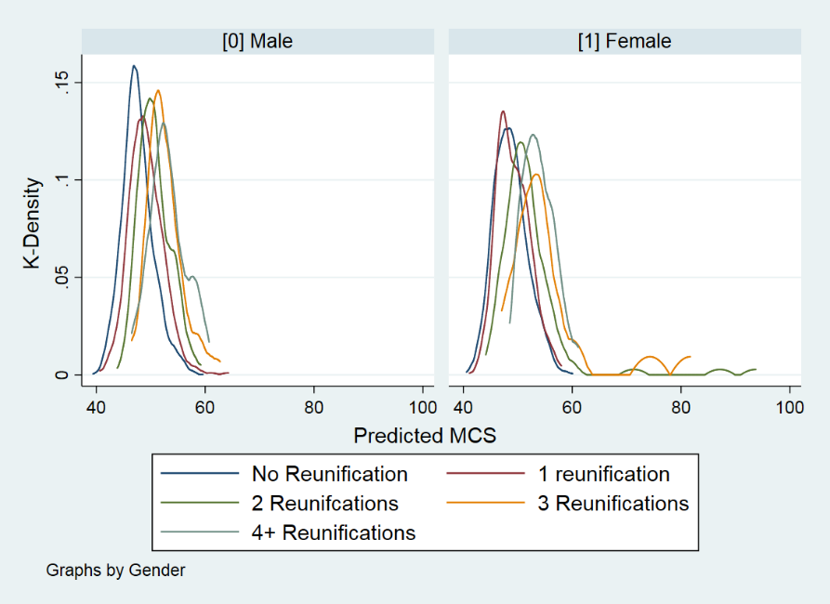

Figure A2: Kernel density distributions of predicted MCS outcomes, excluding siblings in the reunification process

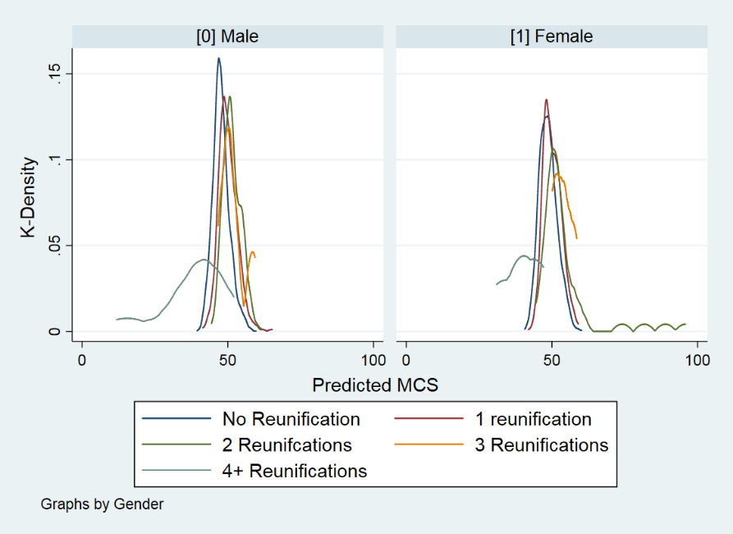

Figure A3: Kernel density distributions of predicted MCS outcomes, excluding siblings in the reunification process, sample restricted to individuals with families to reunite with.

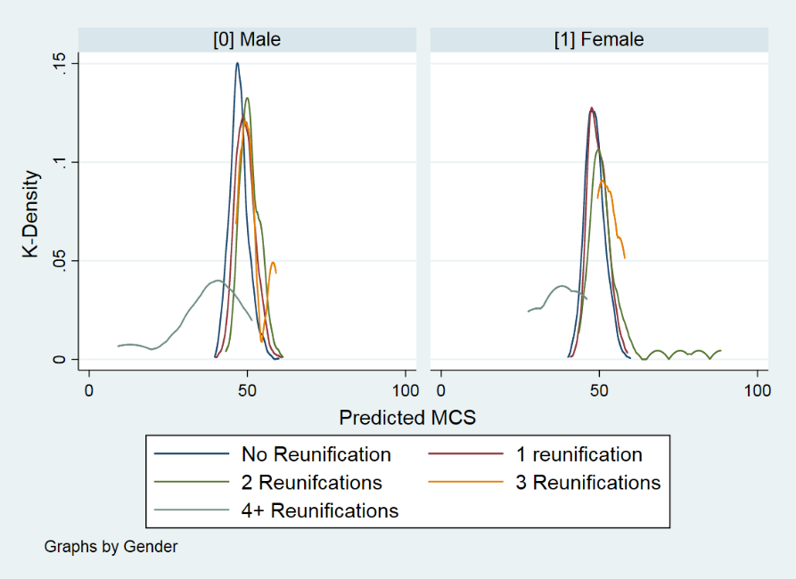

Control variables include: employment status, type of housing, asylum status, knowledge of the German language, meeting people of the same nationality and meeting people of German nationality as well as time from interview to first reunification, time from interview to first reunification squared, PCS, participation in integration courses, number of individuals with a migration background in the area and survey year.

Further, Table A5 provides the gendered analysis from the main manuscript presented as an interaction effect.

Table A5: Unstandardized coefficients and standard errors of the association of family reunification on refugee mental health, interaction effects of gender, interacted control variables not displayed

|  |  |  |  |
| --- | --- | --- | --- |
|  |  |  |  |
|  | Model 1 | Model 2 | Model 3 |
| Family reunification (incl. siblings) | 1.61 |  |  |
|  | (1.28) |  |  |
| Family reunification (incl. siblings) x gender | 1.92 |  |  |
|  | (2.65) |  |  |
| Family reunification squared (incl. siblings) | -0.26 |  |  |
|  | (0.31) |  |  |
| Family reunification squared (incl. siblings) x gender | 0.69 |  |  |
|  | (0.65) |  |  |
| Family reunification (excl. siblings) |  | 3.77** | 3.94** |
|  |  | (1.48) | (1.56) |
| Family reunification (excl. siblings) x gender |  | 1.56 | 1.13 |
|  |  | (3.32) | (3.40) |
| Family reunification squared (excl. siblings) |  | -1.07** | -1.15** |
|  |  | (0.46) | (0.49) |
| Family reunification squared (excl. siblings) x gender |  | 0.42 | 0.54 |
|  |  | (0.79) | (0.82) |
| N | 6610.00 | 6610.00 | 5118.00 |
| Within subject standard deviation (sigma_e) | 9.79 | 9.79 | 9.77 |
| rho | 0.57 | 0.57 | 0.58 |
| R2 - within | 0.06 | 0.06 | 0.06 |

Standard errors in parentheses

* *p* < 0.1, ** *p* < 0.05, *** *p* < 0.01

Control variables include: employment status, type of housing, asylum status, knowledge of the German language, meeting people of the same nationality and meeting people of German nationality as well as time from interview to first reunification, time from interview to first reunification squared, PCS, participation in integration courses, number of individuals with a migration background in the area and survey year – all interacted with gender.

# **Robustness checks**

## **Additional analysis using share of family members remaining in the country of origin as independent variable**

One could argue that the benefit of family reunification lies in unifying the entire nuclear family. Saying this, we also check in how far the share of the overall nuclear family still abroad is associated with refugee mental health. This analysis is only based on refugees who experienced family reunification after the first interview in 2016, as we cannot estimate this share for individuals with prior unifications. An increase of the share individuals remaining abroad is associated with a significant decrease in mental health.

Table A6: Unstandardized coefficients and standard errors of the association of the share of families abroad in Germany on refugee mental health

|  |  |  |  |
| --- | --- | --- | --- |
|  | Model 1  Full | Model 2  Full | Model 3  Restricted |
| Share of family remaining in country of origin (incl. siblings) | -0.14** |  |  |
|  | (0.06) |  |  |
| Share of family remaining in country of origin (excl. siblings) |  | -0.09*** | -0.08*** |
|  |  | (0.02) | (0.02) |
| N | 6610.00 | 6610.00 | 5118.00 |
| Within subject standard deviation (sigma_e) | 9.81 | 9.80 | 9.76 |
| rho | 0.51 | 0.49 | 0.50 |
| R2 - within | 0.05 | 0.05 | 0.06 |

Standard errors in parentheses

* *p* < 0.1, ** *p* < 0.05, *** *p* < 0.01

Control variables include: employment status, type of housing, asylum status, knowledge of the German language, meeting people of the same nationality and meeting people of German nationality as well as time from interview to first reunification, time from interview to first reunification squared, PCS, participation in integration courses, number of individuals with a migration background in the area and survey year.

## **Checking for self-selection into family reunification**

It seems plausible that refugees with better mental health are more likely to realize family reunification as they hold more agency. In order to rule out that the estimated association of family reunification and mental health of refugees is due to a higher MCS *prior* to family reunification, we only use respondents who have not achieved family reunification until 2016 in a cross-sectional robustness check. The independent variable is coded 1 if the respondent was reunited with his/her family between 2016 and 2018, and 0 otherwise. Meanwhile, the dependent variable is the difference in the MCS between 2016 and 2018. With this approach, the actual size of the MCS is not important, but only the de- or increase between 2016 and 2018. As we work with respondents who have not reunited with their family until 2016 this set up allows for a causal interpretation of results. The effect size indicates that the event of family reunification between 2016 and 2018 (coded y/n) increases mental health. Please note that the effect sizes are statistically not significant. This comes as no surprise since only few respondents reunited between these two years (see also Table A2). After all, most reunifications we observe in the data occurs before 2016, given the legal restrictions for family reunification between 2016 and 2018 in Germany. The direction of the effect sizes, however, support our main analyses and conclusion that family reunification increases mental health.

Table A7: Multivariate Linear Regression Analysis on the relative change in MCS before and after family reunification – Unstandardized coefficients and standard errors in parentheses

|  |  |  |  |
| --- | --- | --- | --- |
|  | Model 1 | Model 2 | Model 3 |
|  | Full | Full | Restricted |
| Number of reunifications with family, incl. siblings | 1.81*  (1.10) |  |  |
|  |  |  |  |
| Number of reunifications with family, excl. siblings |  | 2.01 | 2.26* |
|  |  | (1.33) | (1.34) |
| N | 2629.00 | 2629.00 | 1981.00 |
| R2 - within | 0.02 | 0.02 | 0.02 |

Standard errors in parentheses

* *p* < 0.1, ** *p* < 0.05, *** *p* < 0.01

Note: We further control for the first time a respondent was interviewed as a dummy variable. The control variables were observed prior to first family reunification. Control variables include: age groups, gender, family status, having children, education level, country of origin, employment status, type of housing, asylum status, knowledge of the German language, meeting people of the same nationality and meeting people of German nationality as well as time from interview to first reunification, time from interview to first reunification squared, PCS, participation in integration courses, number of individuals with a migration background in the area and survey year.

Table A8: Multivariate Linear Regression Analysis on the relative change in MCS before and after family reunification, by gender – Unstandardized coefficients and standard errors in parentheses

|  |  |  |  |  |  |  |
| --- | --- | --- | --- | --- | --- | --- |
|  |  |  |  |  |  |  |
|  | Model 1 - Male | Model 2 - Female | Model 3 - Male | Model 4 - Female | Model 5 - Male | Model 6 - Female |
| Number of reunifications with family, incl. siblings | 1.14 | 3.80* |  |  |  |  |
|  | (2.03) | (2.24) |  |  |  |  |
| Number of reunifications with family, excl. siblings |  |  | 2.05 | 3.22 | 2.39 | 3.57 |
|  |  |  | (2.00) | (2.90) | (2.15) | (2.90) |
| N | 1665.00 | 954.00 | 1665.00 | 954.00 | 1150.00 | 831.00 |
| R2 - within | 0.03 | 0.01 | 0.03 | 0.01 | 0.03 | 0.00 |

Standard errors in parentheses

* *p* < 0.1, ** *p* < 0.05, *** *p* < 0.01

Note: We further control for the first time a respondent was interviewed as a dummy variable. The control variables were observed prior to first family reunification. Control variables include: age groups, gender, family status, having children, education level, country of origin, employment status, type of housing, asylum status, knowledge of the German language, meeting people of the same nationality and meeting people of German nationality as well as time from interview to first reunification, time from interview to first reunification squared, PCS, participation in integration courses, number of individuals with a migration background in the area and survey year.

# **References**

Deutscher Bundestag. *Drucksache 19/2438: Entwurf eines Gesetzes zur Neuregelung des Familiennachzugs zu subsidiär Schutzberechtigten (Familiennachzugsneuregelungsgesetz)*. , (2018).

Deutscher Bundestag. (2018b). *Drucksache 19/2702: Stellungnahme des Bundesrates und Gegenäußerung der Bundesregierung zu Drucksache 19/2438*. Retrieved from Deutscher Bundestag website: http://dip21.bundestag.de/dip21/btd/19/027/1902702.pdf

Deutscher Bundestag. *Drucksache 19/2740: Beschlussempfehlung und Bericht des Ausschusses für Inneres und Heimat (4. Ausschuss)*. , (2018).

1. All asylum seekers receive a residence permit based on their pending asylum procedure (Art. 55 of the Asylum Procedure Act).
2. For our analysis, we have grouped both together.