

*Journal of Geophysical Research-Biogeosciences*

Supporting Information for

**Land management explains the contrasting greening pattern across China–Russia border based on Paired Land Use Experiment approach**

Tiexi Chen1, 2*, Han Dolman3, 4, Zhanli Sun5  Ning Zeng6, Haiyang Gao7, Lijuan Miao1, Xueqiong Wei1, Chaofan Li1, Qifei Han1, Tingting Shi8, Guojie Wang1, Shengjie Zhou1, Chuanzhuang Liang1, Xin Chen1

1 Collaborative Innovation Center on Forecast and Evaluation of Meteorological Disaster, School of Geographical Sciences, Nanjing University of Information Science & Technology, Nanjing 210044, China

2 School of Geographical Sciences, Qinghai Normal University, Xining 810008, China

3 NIOZ Royal Netherlands Institute for Sea Research, Den Burg 1790 AB, Texel, The Netherlands

4 Department of Earth Sciences, Vrije Universiteit Amsterdam, Amsterdam 1081 HV, The Netherlands

5 Leibniz Institute of Agricultural Development in Transition Economies (IAMO), Theodor–Lieser–Str.2, Halle (Saale) 06120, Germany

6 Department of Atmospheric and Oceanic Science and Earth System Science Interdisciplinary Center, University of Maryland, College Park, Maryland 20742, USA

7 School of Atmospheric Physics, Nanjing University of Information Science and Technology, Nanjing, 210044, China

8 School of Applied Meteorology, Nanjing University of Information Science & Technology, Nanjing 210044, China

**Contents of this file**

Figures S1 to S5

Table S1

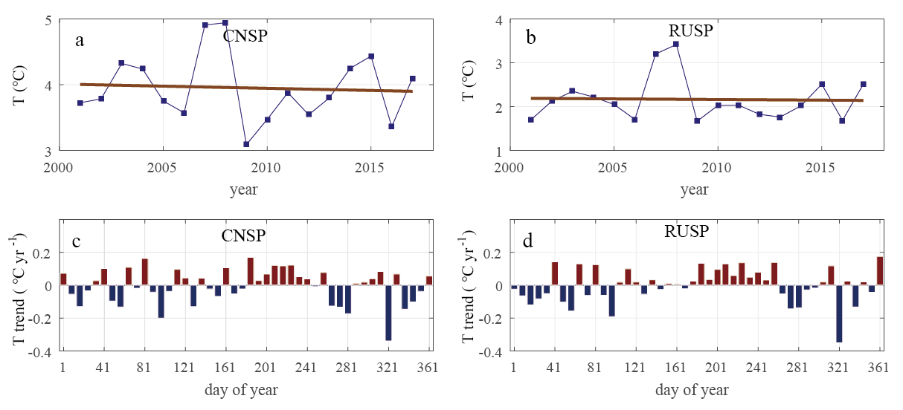

**Figure. S1** Trends of surface air temperature (T) from stations during 2001-2017. (a), (b) Interannual time series and linear fits of surface air temperature using ISD and CMA records during 2001-2017 of CNSP and RUSP respectively. (c), (d) Linear trends during 2001-2017 of each 8-day of CNSP and RUSP.

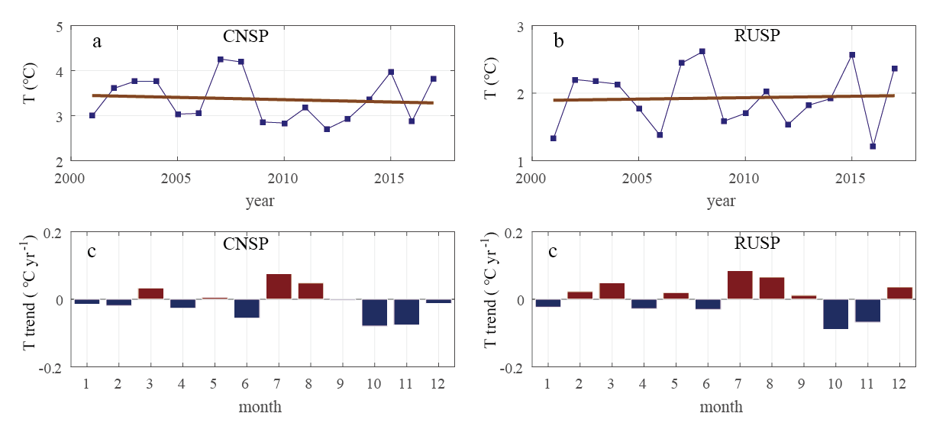

**Figure. S2** Trends of surface air temperature (T) of CRU TS 4.02 gridded data during 2001-2017. (a), (b) Interannual time series and linear fits of surface air temperature during 2001-2017 of CNSP and RUSP respectively. (c), (d) Linear trends during 2001-2017 of each month of CNSP and RUSP.

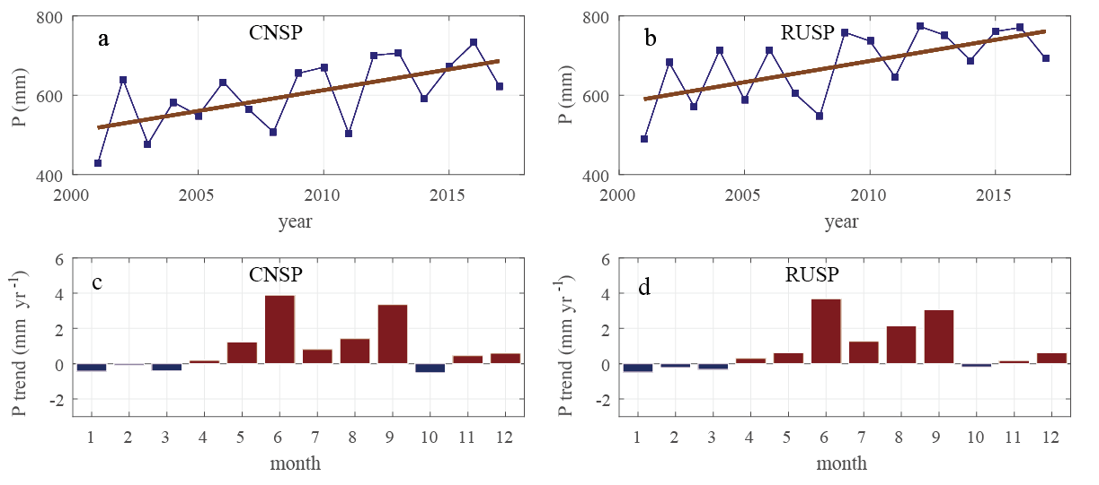

**Figure. S3** Trends of precipitation (P) using CRU TS 4.02 gridded data during 2001-2017. (a), (b) Interannual time series and linear fits of annual precipitation during 2001-2017 of CNSP and RUSP respectively. (c), (d) Linear trends during 2001-2017 of each month of CNSP and RUSP.



**Figure. S4** Cumulative correlation matrix (CCM) of annual LAI with temperature or precipitation. A point at x-axis row and y axis column means the correlations was calculated by the annual mean of x-axis to y-axis month months with annual LAI. (a), (b) CCM of annual LAI and CRU temperature data of CNSP and RUSP respectively. (c), (d) CCM of annual LAI and CRU precipitation data of CNSP and RUSP respectively.

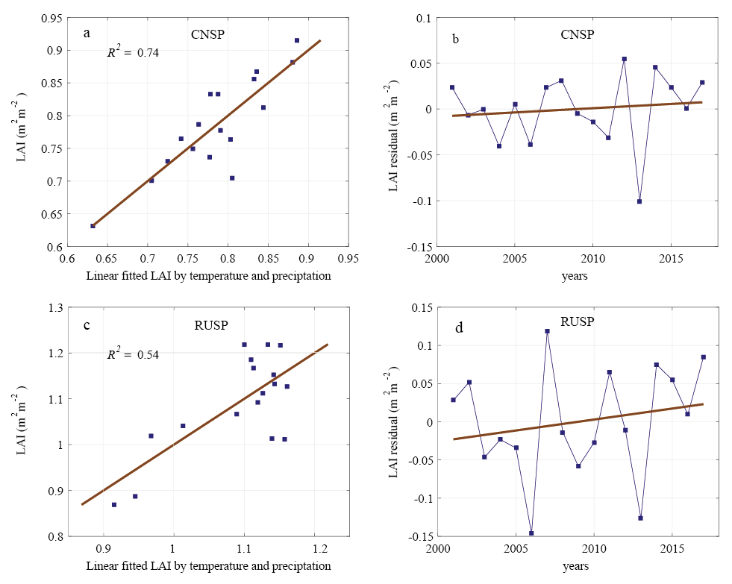

**Figure. S5** Linear regression analysis of LAI with temperature and precipitation as independent variables of the CNSP and RUSP regions. (a), (b) linear fit LAI using July temperature and May-June precipitation, and the residuals of CNSP. (c), (d) linear fit LAI using July-September temperature and April-May precipitation, and the residuals of RUSP.

**Table S1** Correlation coefficients (r) between CRU regional averages and site measurements of annual and monthly records during 2001-2017. All values are significant values at the level p < 0.01.

|  |  |  |  |  |  |
| --- | --- | --- | --- | --- | --- |
| Letter | site name | Temperature | | Precipitation | |
|  |  | annual | monthly | annual | monthly |
| FJ | FUJIN | 0.919 | 0.999 | 0.809 | 0.912 |
| BQ | BAOQING | 0.852 | 0.999 | 0.742 | 0.895 |
|  | China sites average | 0.917 | 0.999 | 0.854 | 0.944 |
| T | TROICKOE | 0.839 | 0.998 |  |  |
| E | EKATERINO-NIKOL''SKOE | 0.915 | 0.998 |  |  |
| B | BIROBIDZHAN | 0.783 | 0.998 |  |  |
| S | SMIDOVICH | 0.749 | 0.998 |  |  |
| N | NOVY | 0.820 | 0.998 |  |  |
|  | Russia sites average | 0.863 | 0.998 |  |  |