Predator or Prey? - Effects of Farm Growth on Neighbouring Farms

Franziska Appel and Alfons Balmann

On-Line Appendices.

Appendix A:
Table A 1 Cluster characteristics (Appel and Balmann 2019)
 | Cluster 1  (“negligent gamblers”) |  | Cluster 2  (“missed opportunities”) |  | Cluster 3  (“solid farm managers”) |  | Cluster 4  (“successful pathbreakers”)
Variable | Mean | Std. dev. | Mean | Std. dev. | Mean | Std. dev. | Mean | Std. dev.
Initial farm size (ha) | 991 | 420.86 | 1,020.64 | 407.91 | 758.52 | 261.92 | 1,288.24 | 356.35
Initial equity capital (€1,000) | 813.02 | 150.04 | 815.46 | 153.11 | 705.78 | 103.88 | 920.56 | 127.75
Production cost factor ^{a)} | 0.94 | 0.05 | 0.99 | 0.09 | 1.05 | 1.11 | 0.98 | 0.04
Av. equity capital (€1,000) | 439.79 | 1,824.05 | 1,377.92 | 1,350.30 | 1,149.34 | 1,179.39 | 2,723.19 | 1,394.98
Final equity capital (€1,000) | -2,584.32 | 2,509.41 | 1,040.44 | 2,726.24 | 937.13 | 2,357.27 | 4,297.49 | 1,491.21
Av. profit p.a. (€1,000) | 100.59 | 777.14 | 375.93 | 586.17 | 290.44 | 587.52 | 934.30 | 758.97
Final profit (€1,000) | -460.86 | 279.45 | 135.57 | 718.19 | 134.89 | 889.23 | 696.71 | 449.55
Av. size (ha) | 1,014.90 | 975.20 | 1,218.36 | 1,147.19 | 911.27 | 852.56 | 2,272.79 | 1,356.47
Final size (ha) | 0 | 0 | 1,300.27 | 1,519.69 | 934.58 | 1,525.67 | 4,177.35 | 1,429.82
Av. revenue (€1,000) | 3,082.56 | 1,939.46 | 3,555.01 | 2,723.13 | 2,711.58 | 2,712.36 | 6,571.81 | 4,025.20
Gender (1=female) | 0.40 | 0.49 | 0.44 | 0.50 | 0.26 | 0.44 | 0.24 | 0.42
Age | 24 | 2.10 | 25.49 | 2.89 | 26.24 | 3.46 | 27.65 | 3.78
Knowledge of farm management ^{b)} | 2.88 | 1.17 | 2.86 | 0.95 | 2.86 | 1.13 | 2.08 | 0.64
HLL (safe choices) | 5.5 | 1.50 | 4.95 | 2.52 | 5.75 | 1.90 | 5.76 | 2.29
Risk (self-assessment) ^{c)} | 4.7 | 1.42 | 4.55 | 1.99 | 5.16 | 1.83 | 4.35 | 1.57
Maximising ^{d)} | 3.35 | 0.55 | 3.03 | 0.58 | 2.97 | 0.39 | 3.23 | 0.35
Rational^{e)} | 3.78 | 0.54 | 3.85 | 0.57 | 4 | 0.47 | 4.01 | 0.30
Intuitive ^{e)} | 3.46 | 0.79 | 3.56 | 0.70 | 3.14 | 0.71 | 3.04 | 0.78
Dependent ^{e)} | 2.96 | 0.79 | 3.09 | 0.80 | 3.20 | 0.80 | 3.33 | 0.64
Avoidant ^{e)} | 2.44 | 0.94 | 2.62 | 1.10 | 2.68 | 0.85 | 2.92 | 0.96
Spontaneous ^{e)} | 2.98 | 0.77 | 2.93 | 0.84 | 2.81 | 0.87 | 2.88 | 0.66
Number of farms | 10 |  | 55 |  | 61 |  | 17
Note: a) factor multiplied by variable costs of the farm for each production activity
b) I have sound knowledge of agricultural management. - 1 = strongly agree, 2 = agree, 3 = neither agree nor disagree, 4 = disagree, and 5 = strongly disagree
c) 0 = highly risk tolerant, …, 10 = completely risk averse
d) 1 = strong satisficing behaviour, …, 5 = strong maximising behaviour
e) 1= very low expression of the resp. characteristic, …, 5 = very high expression of the resp. characteristic

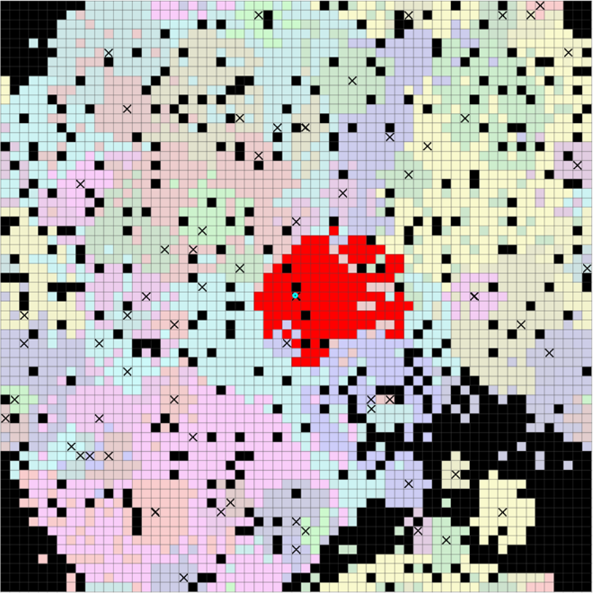 | 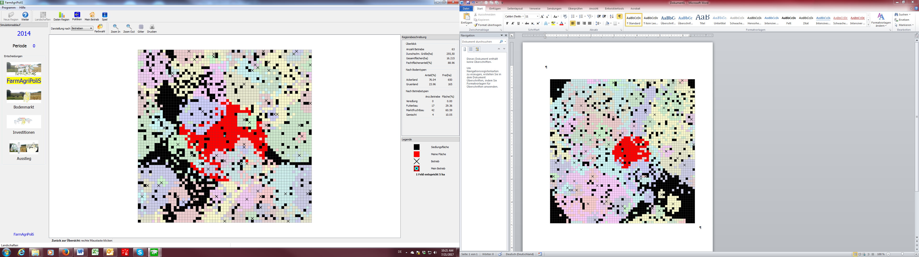
(a) Scenarios 1 to 3 and 7 to 9 | (b) Scenarios 4 to 6
Note: The participant’s farm is located in the centre. The initially operated fields are marked red, farmsteads are marked as crossed cells, and black cells indicate areas of non-agricultural use
Figure A 1 Initialization of model region

Table A 2 Description of variables used in SEM
Variable | Description
Farm 2 | Scenario proxy for scenarios 4 - 6
Farm 3 | Scenario proxy for scenarios 7 - 9
Price 1 | Scenario proxy for scenarios 2, 5, 8
Price 2 | Scenario proxy for scenarios 3, 6, 9
CLUSTER1 | Proxy for a participant who belongs to Cluster 1 (“negligent gamblers”)
CLUSTER4 | Proxy for a participant who belongs to Cluster 4 (“successful pathbreakers”)
ln Distance | Distance between a model farm and the farm run by the participant. In accordance with the gravity model of trade (cf. Isard 1954, Tinbergen 1962), we use the logarithmic distance to account for the spatial interaction.
Period | Periods 0 - 19 of the experiment, which are equivalent to 20 simulated years
Equity capital participant^{a)} | Relative difference in equity capital of the participant’s farm from the computer benchmark (same farm run by a computer agent) in the resp. period. This accounts for different initializations as well as the performance of the respective computer agents, which serves as the benchmark.  $$relative{Equity}_{Participant}^{Period=i}=\frac{\left({Equity}_{Participant}^{Period=i}-{Equity}_{Benchmark}^{Period=i}\right)}{{Equity}_{Benchmark}^{Period=0}}$$  With i = 0 to 19
Equity capital ^{a)} | Relative difference in equity capital of each farm in the simulated region from the equity capital that this farm has in the benchmark situation (all farms run by computer agent; no human participant influencing the region).  $${relativeEquity}_{Farm=j}^{Period=i}=\frac{\left({Equity}_{Farm=j}^{Period=i}-{Equity}_{{Farm=j}_{Benchmark}}^{Period=i}\right)}{{Equity}_{Benchmark}^{Period=0}}$$  With i = 0 to 19 and j = 0 to 62
Farm size ^{a)} | analogous to previous description  $${relativeSize}_{Farm=j}^{Period=i}=\frac{\left({Size}_{Farm=j}^{Period=i}-{Size}_{{Farm=j}_{Benchmark}}^{Period=i}\right)}{{Size}_{Benchmark}^{Period=0}}$$  With i = 0 to 19 and j = 0 to 62
Rental price arable land ^{a)} | analogous to previous description  $${rel.RentalPrice}_{Farm=j}^{Period=i}=\frac{\left({RentalPrice}_{Farm=j}^{Period=i}-{RentalPrice}_{{Farm=j}_{Benchmark}}^{Period=i}\right)}{{RentalPrice}_{Benchmark}^{Period=0}}$$  For arable land; With i = 0 to 19 and j = 0 to 62
Rental price grassland ^{a)} | analogous to previous description  $${rel.RentalPrice}_{Farm=j}^{Period=i}=\frac{\left({RentalPrice}_{Farm=j}^{Period=i}-{RentalPrice}_{{Farm=j}_{Benchmark}}^{Period=i}\right)}{{RentalPrice}_{Benchmark}^{Period=0}}$$  For grassland; With i = 0 to 19 and j = 0 to 62
a) relative to benchmark

