Supplemental material
Appendix A
The visualization below shows collaborative inventor-inventor relations that cross regions’ boundaries. It is important to note that only intense interregional collaborative ties (>the 95th percentile) at the aggregate level (1980-2014) are shown.
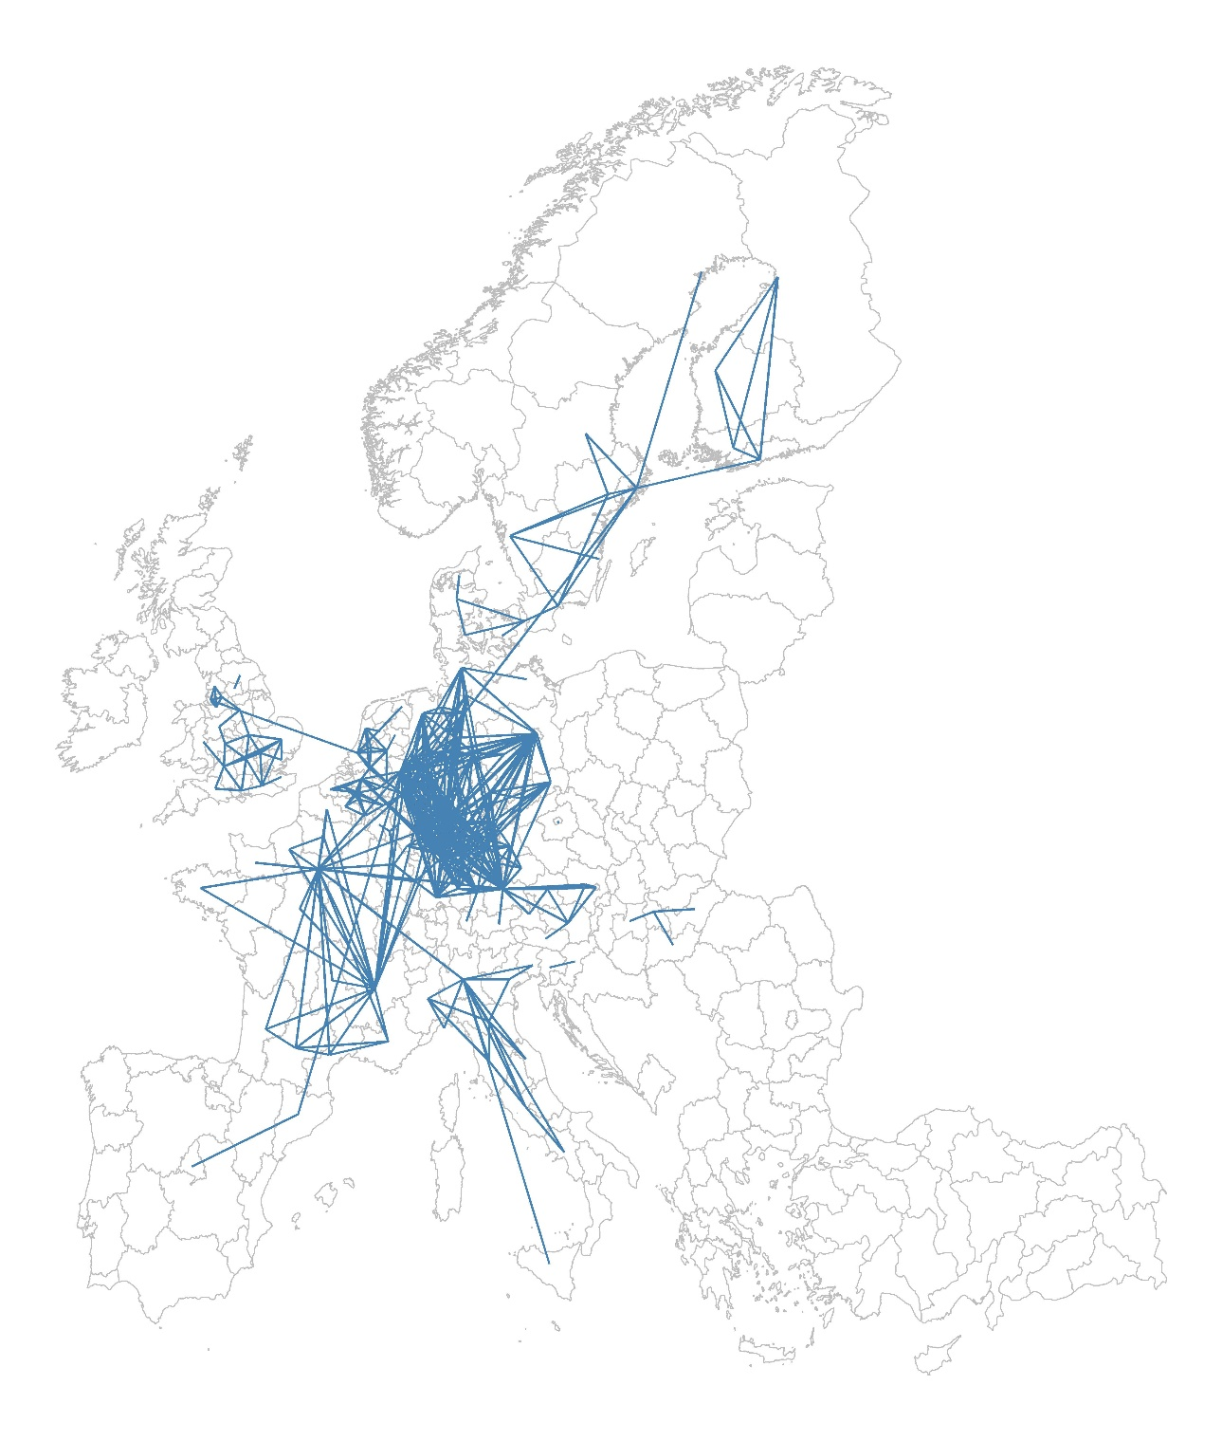

Appendix B
To substantiate that inventors tend to utilize technologies similar to the ones that they used in the past, we selected 10,000 random patents developed by 392,596 inventors who filed more than one patent between 1984 and 2014. To exclude extreme cases (e.g., an inventor with >600 patents), we included inventors whose number of inventions is below the 95th percentile. Then, we calculated the Jaccard similarity index between technology codes included on the randomly selected focal patent, and the ones on other patents filled by the same inventor. To create a null expectation, we selected a set of random patents (equal to the number of patents filed by the inventor of the focal patent) and calculated the Jaccard similarity index between the technology codes of the focal patent and the ones of the random patents. The result (below) shows that inventors tend to file patents with technology codes that are significantly similar with the ones in their portfolios.

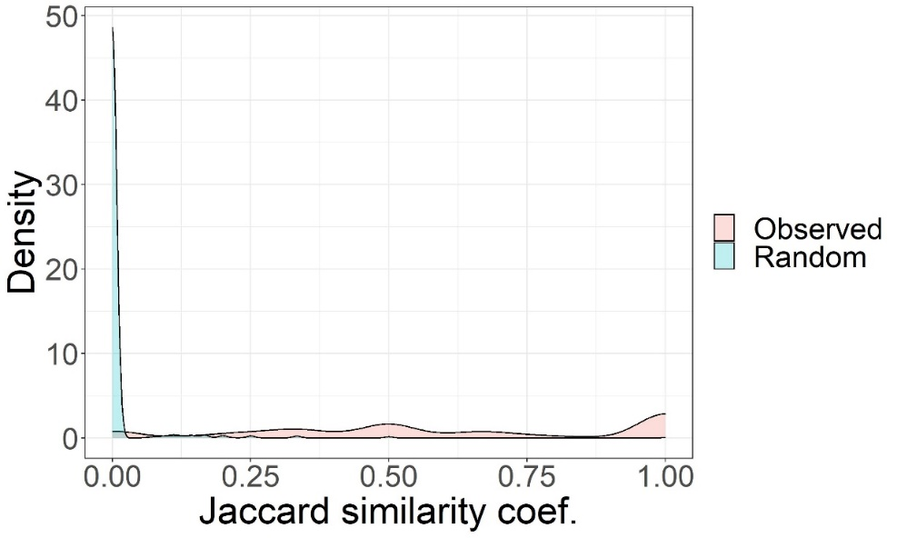

Appendix C
The three-dimensional scatter plot illustrates how regions’ inventor and community number, and technological diversity are related. The scatterplot suggests that the number of inventors and the number of communities are highly correlated, whereas these two variables are not strongly correlated with technological diversity. It is worth noting that the values on the x and y axes are log-transformed. Technological diversity corresponds to the median of the distribution of the Shannon entropy coefficients for all communities in each region. The colour of dots corresponds to their technological diversity values.

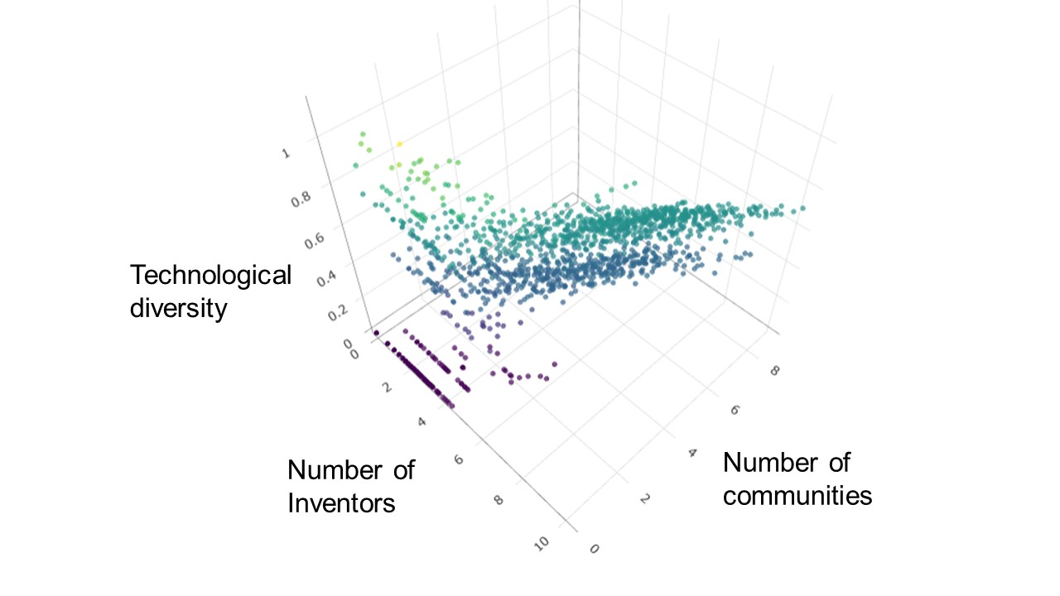

Appendix D
Statistic | N | Mean | St. Dev. | Min | Pctl(25) | Pctl(75) | Max
ATYPICAL | 1,526 | 0.24 | 0.10 | 0.00 | 0.21 | 0.29 | 0.62
SMALLWORLDNESS | 1,526 | 0 | 1 | -1.27 | -1.27 | 0.92 | 1.35
SPECIALIZATION | 1,526 | 0.39 | 0.20 | 0.00 | 0.36 | 0.50 | 1.00
SICT | 1,526 | 0.01 | 0.05 | 0 | 0 | 0.01 | 0.5
SIMILARITY | 1,526 | 0.19 | 0.26 | 0 | 0 | 0.4 | 1
RELATEDNESS | 1,526 | 16.74 | 11.24 | 0.00 | 5.32 | 25.76 | 44.55
COMPLEXITY | 1,526 | 78.16 | 14.88 | 0.00 | 73.95 | 87.38 | 100.00
INTERREGIONAL | 1,526 | 0.54 | 0.16 | 0.00 | 0.45 | 0.63 | 1.00
POPULATION | 1,526 | 13.13 | 1.03 | 7.42 | 12.83 | 13.70 | 15.38
DENSITY | 1,526 | 0.01 | 0.02 | 0.00 | 0.0002 | 0.002 | 0.40
ISOLATE | 1,526 | 0.71 | 0.18 | 0.17 | 0.57 | 0.82 | 1.00
COMMUNITY | 1,526 | 0.07 | 0.04 | 0.00 | 0.05 | 0.09 | 0.33
Note: we excluded 58 region-times (form 35 regions) that lack population data in early time-windows. SMALLWORLDNESS is a z-score.

 | 1) | 2) | 3) | 4) | 5) | 6) | 7) | 8) | 9) | 10) | 11) | 12)
1) ATYPICAL | 1
2) SMALLWORLDNESS | 0.27 | 1
3) SPECIALIZATION | 0.25 | 0.33 | 1
4) SICT | 0.02 | -0.06 | 0.05 | 1
5) SIMILARITY | 0.1 | 0.02 | 0.08 | 0.43 | 1
6) RELATEDNESS | 0.34 | 0.48 | 0.28 | -0.06 | 0.39 | 1
7) COMPLEXITY | 0.25 | 0.31 | 0.22 | -0.01 | 0.2 | 0.59 | 1
8) INTERREGIONAL | 0.05 | 0.02 | -0.02 | -0.05 | -0.07 | -0.05 | -0.1 | 1
9) POPULATION | 0.06 | 0.02 | 0.06 | 0 | 0.16 | 0.28 | 0.11 | -0.12 | 1
10) DENSITY | -0.13 | -0.1 | 0.11 | 0.14 | -0.06 | -0.29 | -0.21 | 0.03 | -0.06 | 1
11) ISOLATE | -0.19 | -0.17 | -0.33 | -0.14 | -0.53 | -0.53 | -0.24 | 0 | -0.16 | -0.19 | 1
12) COMMUNITY | 0.18 | 0.36 | 0.5 | 0.09 | 0.25 | 0.35 | 0.16 | 0.08 | 0.03 | 0.42 | -0.79 | 1

Appendix E
Panel A illustrates the kernel density estimates of the share of atypical patents in regions between 1984 and 2014. The visualizations in Panel B and C show the distribution of the full panel regression model compared to theoretical expectation based on the normal distribution of residuals (i.e., blue cure in Panel B and blue line in Panel C). Panel B and C suggest that the residuals rather follow a sharply peaked distribution (i.e., a Leptokurtic distribution: kurtosis>3).

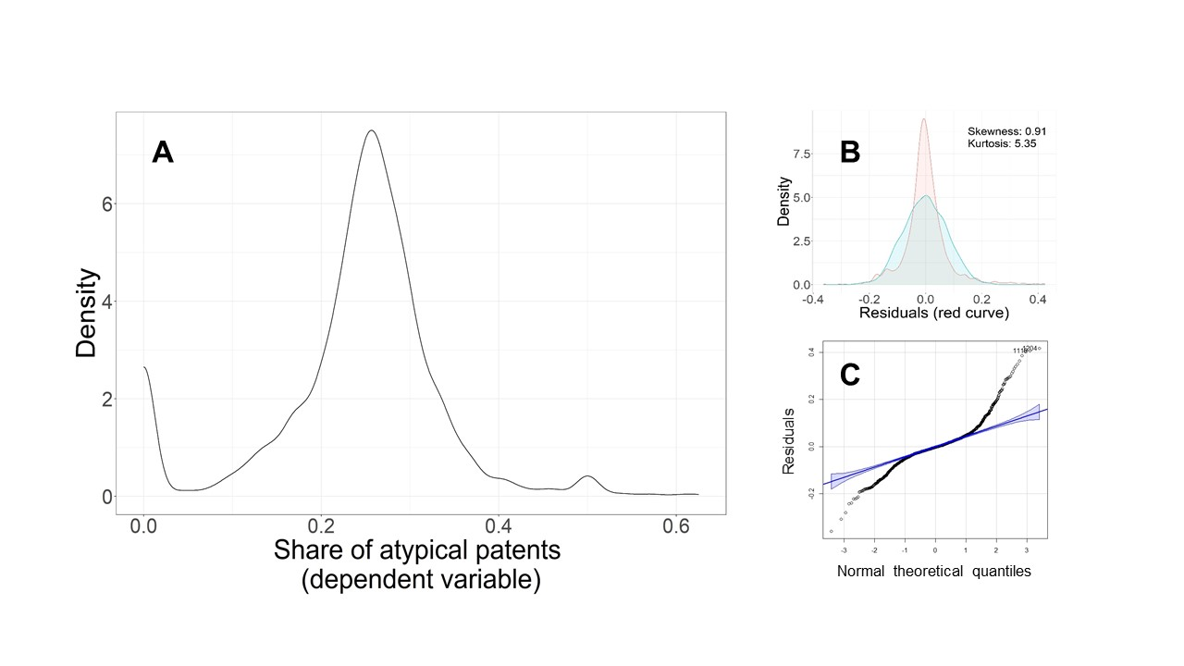

Appendix F
The graph below shows the estimated variance inflation factors (VIF) of the full model as diagnostics for the multicollinearity. The graph demonstrates relatively high VIF values for COMMUNITY, ISOLATE, and RELATEDNESS.

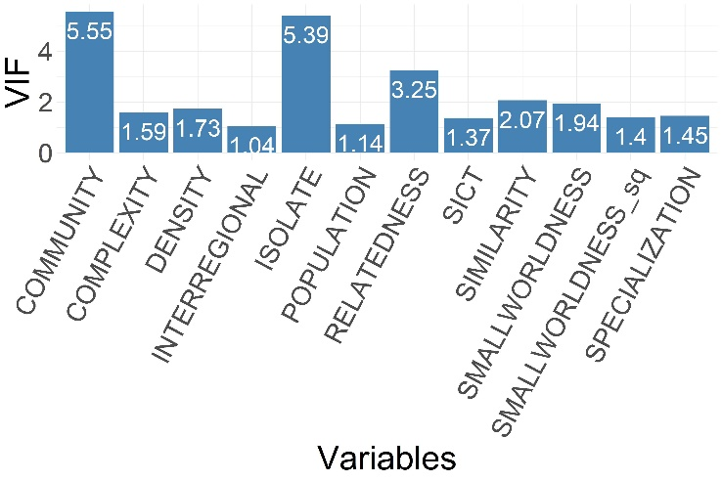

Appendix G
Using the mean (Model 2) and standard deviation (Model 3) of the distribution of the Hirschman-Herfindahl indices for technologies embedded in each community to create alternative variables approximating the degree of regions’ specialization.

 | Dependent variable: share of atypical patents
 | (1) | (2) | (3)
SPECIALIZATION (median) | 0.0558**
 | (0.0220)
SPECIALIZATION (mean) |  | 0.0645***
 |  | (0.0239)
SPECIALIZATION (standard deviation) |  |  | 0.1349**
 |  |  | (0.0538)
SMALLWORLDNESS | 0.0115** | 0.0111** | 0.0064
 | (0.0052) | (0.0051) | (0.0043)
SMALLWORLDNESS^2 | 0.0007 | 0.0009 | 0.0014
 | (0.0042) | (0.0041) | (0.0043)
SICT | 0.1039** | 0.1029** | 0.0965**
 | (0.0493) | (0.0493) | (0.0463)
SIMILARITY | -0.0231** | -0.0225** | -0.0205**
 | (0.0094) | (0.0094) | (0.0095)
RELATEDNESS | -0.0014* | -0.0014* | -0.0015**
 | (0.0007) | (0.0008) | (0.0008)
COMPLEXITY | -0.0002 | -0.0002 | -0.0002
 | (0.0004) | (0.0004) | (0.0004)
INTERREGIONAL | -0.0572* | -0.0573* | -0.0512
 | (0.0346) | (0.0347) | (0.0349)
POPULATION | -0.0001 | -0.00001 | -0.0007
 | (0.0029) | (0.0029) | (0.0030)
ISOLATE | 0.1336* | 0.1406* | 0.1942***
 | (0.0792) | (0.0782) | (0.0693)
COMMUNITY | 0.0313 | -0.0022 | 0.1828
 | (0.3192) | (0.3255) | (0.2765)
DENSITY | 0.1943 | 0.2343 | 0.4026*
 | (0.2298) | (0.2291) | (0.2363)
Region FE | YES | YES | YES
Time FE | YES | YES | YES
Observations | 1,526 | 1,526 | 1,526
R² | 0.4172 | 0.4178 | 0.4182
Adjusted R² | 0.2862 | 0.2869 | 0.2873
Residual Std. Error (df = 1245) | 0.0847 | 0.0846 | 0.0846
Note: | *p<0.1; **p<0.05; ***p<0.01

Appendix H
To capture dynamics across each consequent time-windows, Model 2 includes an extra independent variable that corresponds to the dependent variable of the previous time-window. The sign and significance of the variables of interest do not change

 | Dependent variable: share of atypical patents
 | (1) | (2)
SMALLWORLDNESS | 0.0115** | 0.0123**
 | (0.0052) | (0.0054)
SMALLWORLDNESS^2 | 0.0007 | 0.0009
 | (0.0042) | (0.0043)
SPECIALIZATION | 0.0558** | 0.0614***
 | (0.0220) | (0.0220)
SICT | 0.1039** | 0.1129**
 | (0.0493) | (0.0540)
SIMILARITY | -0.0231** | -0.0249**
 | (0.0094) | (0.0097)
RELATEDNESS | -0.0014* | -0.0013*
 | (0.0007) | (0.0008)
COMPLEXITY | -0.0002 | -0.0002
 | (0.0004) | (0.0004)
INTERREGIONAL | -0.0572* | -0.0566
 | (0.0346) | (0.0347)
POPULATION | -0.0001 | -0.0006
 | (0.0029) | (0.0029)
ISOLATE | 0.1336* | 0.1274
 | (0.0792) | (0.0798)
COMMUNITY | 0.0313 | 0.0844
 | (0.3192) | (0.3081)
DENSITY | 0.1943 | 0.1107
 | (0.2298) | (0.2292)
ATYPICAL_t0 |  | -0.1254***
 |  | (0.0355)
Region FE | YES | YES
Time FE | YES | YES
Observations | 1,526 | 1,526
R² | 0.4172 | 0.4265
Adjusted R² | 0.2862 | 0.2970
Residual Std. Error | 0.0847 (df = 1245) | 0.0840 (df = 1244)
Note: | *p<0.1; **p<0.05; ***p<0.01

Appendix I
Model 2 includes a variable that captures the effect of assortativity (also known as assortative mixing) in regions’ network of places (ASSORTATIVITY). This variable is the Pearson correlations between places’ degrees that are directly connected. The result does not provide evidence for any association between assortativity and the increase in the share of atypical inventions.

 | Dependent variable: share of atypical patents
 | (1) | (2)
ASSORTATIVITY |  | -0.0227
 |  | (0.0151)
SMALLWORLDNESS | 0.0115** | 0.0158**
 | (0.0052) | (0.0064)
SMALLWORLDNESS^2 | 0.0007 | -0.0004
 | (0.0042) | (0.0043)
SPECIALIZATION | 0.0558** | 0.0436*
 | (0.0220) | (0.0231)
SICT | 0.1039** | 0.0986*
 | (0.0493) | (0.0504)
SIMILARITY | -0.0231** | -0.0231**
 | (0.0094) | (0.0094)
RELATEDNESS | -0.0014* | -0.0012*
 | (0.0007) | (0.0007)
COMPLEXITY | -0.0002 | -0.0002
 | (0.0004) | (0.0004)
INTERREGIONAL | -0.0572* | -0.0608*
 | (0.0346) | (0.0349)
POPULATION | -0.0001 | 0.0001
 | (0.0029) | (0.0029)
ISOLATE | 0.1336* | 0.1122
 | (0.0792) | (0.0832)
COMMUNITY | 0.0313 | -0.0546
 | (0.3192) | (0.3362)
DENSITY | 0.1943 | 0.1456
 | (0.2298) | (0.2274)
Region FE | YES | YES
Time FE | YES | YES
Observations | 1,526 | 1,526
R² | 0.4172 | 0.4190
Adjusted R² | 0.2862 | 0.2878
Residual Std. Error | 0.0847 (df = 1245) | 0.0846 (df = 1244)
Note: | *p<0.1; **p<0.05; ***p<0.01

Appendix J
Model 2 includes the normalized median size of communities (COMMUNITY_median) instead of original variable COMMUNITY that corresponds to the normalized community number (Model 1). These two variables are weakly correlated (the Pearson correlation coefficients: 0.26). This specification led to a slightly better predictive power of models. The sign and significance of the variables of interests are consistent with the ones of Model 1.

 | Dependent variable: share of atypical patents
 | (1) | (2) | (3)
SMALLWORLDNESS | 0.0115*** | 0.0116*** | 0.0114***
 | (0.0040) | (0.0037) | (0.0040)
SMALLWORLDNESS^2 | 0.0007 | 0.0008 | 0.0008
 | (0.0055) | (0.0055) | (0.0055)
SPECIALIZATION | 0.0558*** | 0.0587*** | 0.0576***
 | (0.0179) | (0.0163) | (0.0180)
SICT | 0.1039* | 0.1010* | 0.1008*
 | (0.0594) | (0.0594) | (0.0595)
SIMILARITY | -0.0231 | -0.0236 | -0.0233
 | (0.0153) | (0.0151) | (0.0153)
RELATEDNESS | -0.0014* | -0.0014* | -0.0014*
 | (0.0007) | (0.0007) | (0.0007)
COMPLEXITY | -0.0002 | -0.0003 | -0.0003
 | (0.0002) | (0.0002) | (0.0002)
INTERREGIONAL | -0.0572*** | -0.0567*** | -0.0568***
 | (0.0217) | (0.0216) | (0.0217)
POPULATION | -0.0001 | -0.0001 | -0.0001
 | (0.0031) | (0.0031) | (0.0031)
ISOLATE | 0.1336** | 0.1259*** | 0.1318**
 | (0.0569) | (0.0390) | (0.0570)
COMMUNITY | 0.0313 |  | 0.0306
 | (0.2168) |  | (0.2168)
COMMUNITY (median) |  | -0.0174 | -0.0174
 |  | (0.0196) | (0.0196)
DENSITY | 0.1943 | 0.2892 | 0.2804
 | (0.1927) | (0.2064) | (0.2158)
Region FE | YES | YES | YES
Time FE | YES | YES | YES
Observations | 1,526 | 1,526 | 1,526
R² | 0.4172 | 0.4176 | 0.4176
Adjusted R² | 0.2862 | 0.2866 | 0.2860
Residual Std. Error | 0.0847 (df = 1245) | 0.0846 (df = 1245) | 0.0847 (df = 1244)
Note: | *p<0.1; **p<0.05; ***p<0.01

Appendix K
Robustness check through the utilization of a beta regression model.
 | Dependent variable: share of atypical patents
 | FE panel  regression model | Beta regression
SMALLWORLDNESS | 0.0115** | 0.07**
 | (0.0052) | (0.03)
SMALLWORLDNESS^2 | 0.0007 | -0.02
 | (0.0042) | (0.04)
SPECIALIZATION | 0.0558** | 1.00***
 | (0.0220) | (0.14)
SICT | 0.1039** | 1.32***
 | (0.0493) | (0.43)
SIMILARITY | -0.0231** | -0.20*
 | (0.0094) | (0.11)
RELATEDNESS | -0.0014* | -0.01**
 | (0.0007) | (0.01)
COMPLEXITY | -0.0002 | -0.001
 | (0.0004) | (0.002)
INTERREGIONAL | -0.0572* | -0.55***
 | (0.0346) | (0.19)
POPULATION | -0.0001 | -0.01
 | (0.0029) | (0.02)
ISOLATE | 0.1336* | 1.38***
 | (0.0792) | (0.43)
COMMUNITY | 0.0313 | 4.86***
 | (0.3192) | (1.72)
DENSITY | 0.1943 | -3.50**
 | (0.2298) | (1.78)
(phi) |  | 13.23***  (0.48)
Constant |  | -2.49***
 |  | (0.62)
Region FE | YES | YES
Time FE | YES | YES
Observations | 1,526 | 1,526
R2 | 0.4172
Adjusted R2 | 0.2862
Pseudo R-squared |  | 0.5183
Note: | *p<0.1; **p<0.05; ***p<0.01

