Appendix

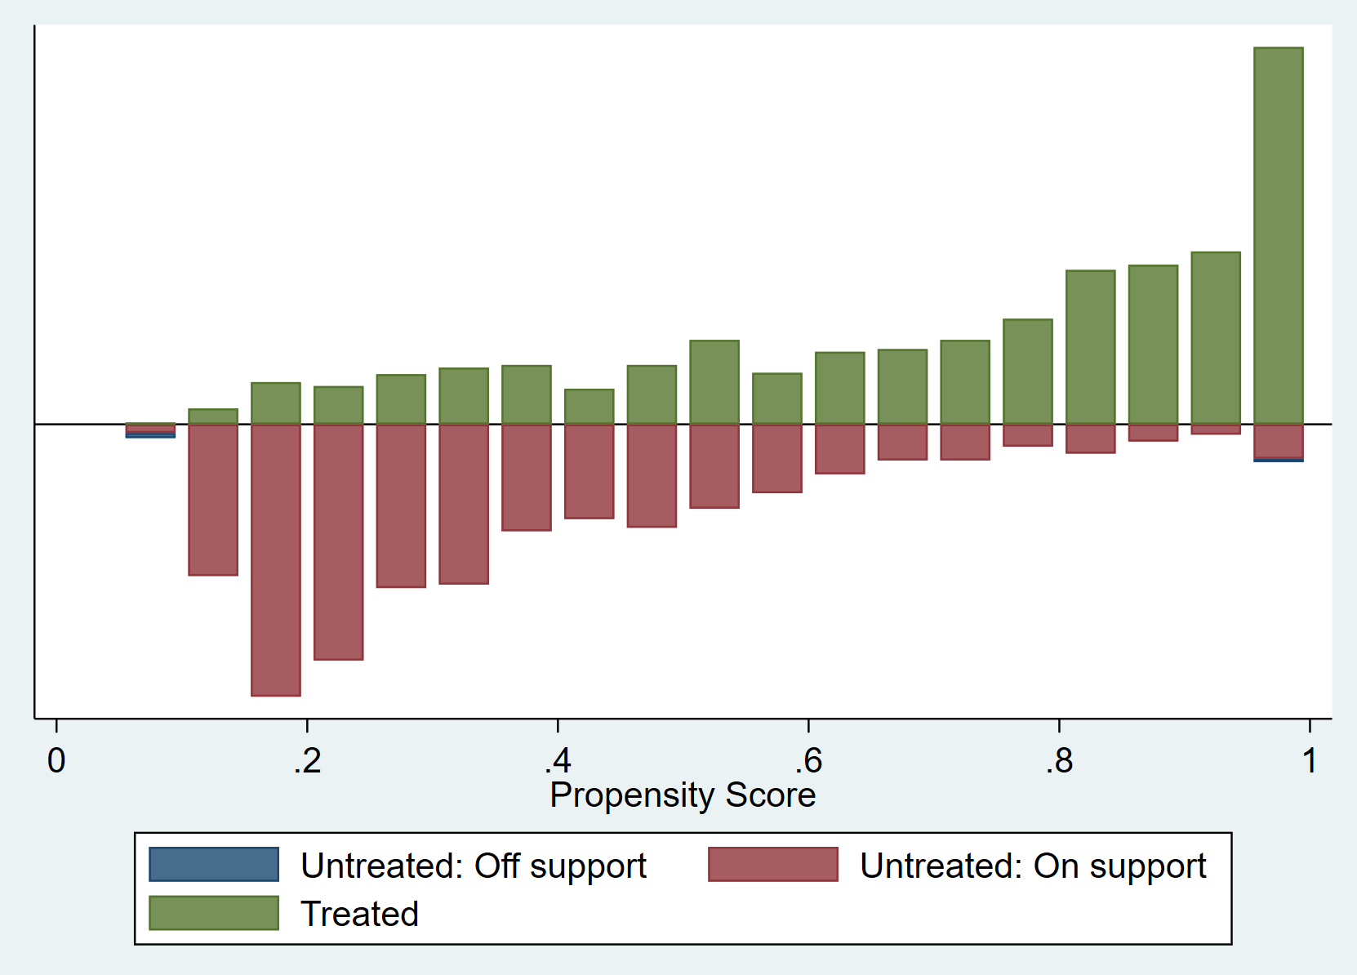

**Figure S1.** Propensity score distribution and common support for propensity score estimation (males)

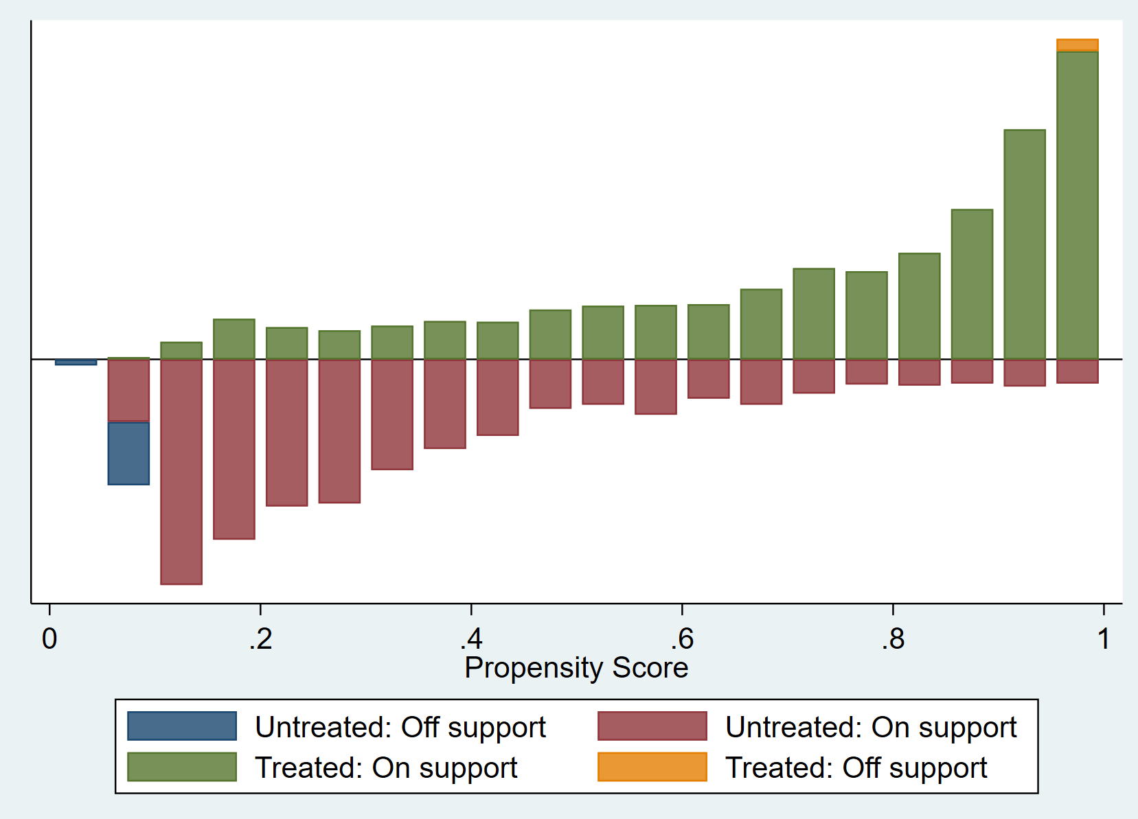

**Figure S2.** Propensity score distribution and common support for propensity score estimation (females)

**Table S1.** PSM quality indicators for males before and after matching by covariates

|  |  |  |
| --- | --- | --- |
|  | Before matching | After matching |
| Pseudo R2 | 0.286 | 0.005 |
| Mean bias | 29.600*** | 5.600 |
| LR χ2 | 889.800 | 18.460 |

Note: ***, **, * denote significance at 1% level, 5% level, and 10% level, respectively.

**Table S2.** PSM quality indicators for females before and after matching by covariates

|  |  |  |
| --- | --- | --- |
|  | Before matching | After matching |
| Pseudo R2 | 0.326 | 0.003 |
| Mean bias | 36.800*** | 3.800 |
| LR χ2 | 1539.960 | 14.66 |

Note: ***, **, * denote significance at 1% level, 5% level, and 10% level, respectively.