**Appendix**

**TABLE A1:** Panel structure of KIHS, 2005-2019

|  |  |  |  |  |  |  |  |  |
| --- | --- | --- | --- | --- | --- | --- | --- | --- |
| Years | Households | in % form | | | | | | |
| 2005 | 2006 | 2007 | 2008 | 2009 | 2010 | 2011 |
| 2005 | 4,771 |  |  |  |  |  |  |  |
| 2006 | 4,863 | 91 |  |  |  |  |  |  |
| 2007 | 4,803 | 71 | 79 |  |  |  |  |  |
| 2008 | 4,995 | 65 | 71 | 91 |  |  |  |  |
| 2009 | 4,984 | 59 | 65 | 82 | 91 |  |  |  |
| 2010 | 4,979 | 56 | 61 | 75 | 83 | 91 |  |  |
| 2011 | 5,010 | 52 | 57 | 70 | 75 | 83 | 91 |  |
| 2012 | 5,006 | 48 | 53 | 65 | 69 | 76 | 83 | 90 |

|  |  |  |  |  |  |  |  |
| --- | --- | --- | --- | --- | --- | --- | --- |
| Years | Households | in % form | | | | | |
| 2013 | 2014 | 2015 | 2016 | 2017 | 2018 |
| 2013 | 5,013 |  |  |  |  |  |  |
| 2014 | 5,006 | 91 |  |  |  |  |  |
| 2015 | 5,016 | 83 | 90 |  |  |  |  |
| 2016 | 5,006 | 78 | 85 | 93 |  |  |  |
| 2017 | 5,016 | 72 | 78 | 85 | 91 |  |  |
| 2018 | 5,015 | 69 | 75 | 82 | 87 | 95 |  |
| 2019 | 5,016 | 66 | 72 | 78 | 83 | 90 | 95 |

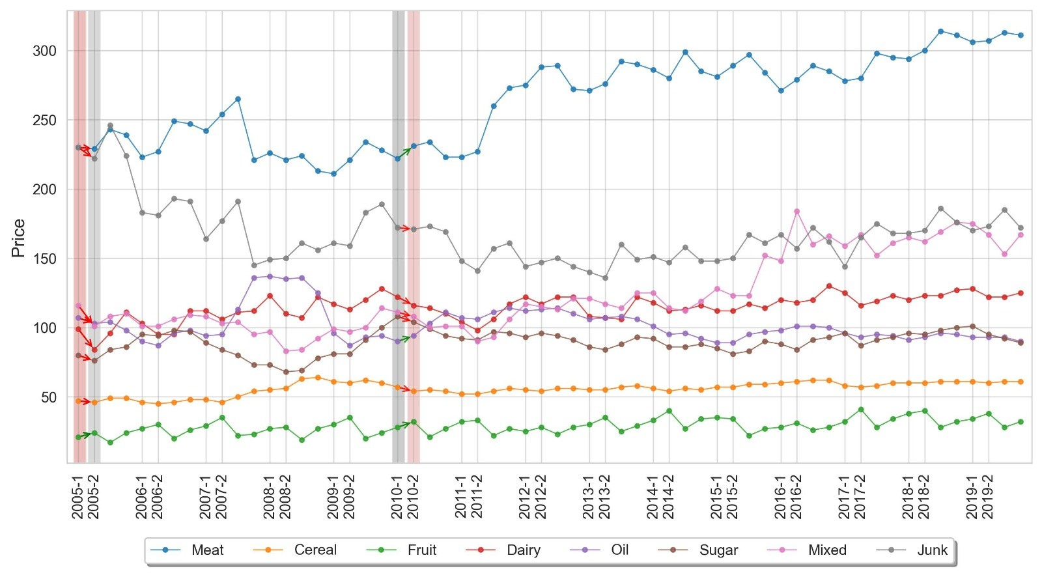

**FIGURE7:** Quality-adjusted prices for food groups

**TABLE A4:** Estimates of the Working-Leser model

|  |  |
| --- | --- |
| Log total food expenditure |  |
| Log total income | 0.012 (8e-5) |
| Laspeyres food price index | 0.408 (0.007) |
| Household head’s age | -3e-4 (2e-5) |
| Household head’s gender | 0.107 (0.001) |
| Household size | 0.101 (1e-4) |
| Education |  |
| Household heads with only basic education | -0.090 (0.001) |
| Household heads with secondary education | -0.042 (0.001) |
| Household heads with high education | 0.061 (0.001) |
| Provinces |  |
| Issyk-Kul | -0.143 (0.001) |
| Jalal-Abad | -0.046 (0.001) |
| Naryn | -0.494 (0.001) |
| Osh | -0.068 (0.001) |
| Talas | -0.027 (0.001) |
| Chui | 0.199 (0.001) |
| Bishkek | 0.159 (0.001) |
| Batken | base outcome |
| Urban | 0.226 (0.001) |
| Rural | base outcome |
| Constant | 4.976 (0.033) |
| Number of observations | 2,371,168 |
| Adjusted R-squared | 0.321 |

*Note:* Robust standard errors are given in parentheses.

**TABLE A5:** Demand elasticities (2005-2019)

|  |  |  |  |  |  |  |  |  |
| --- | --- | --- | --- | --- | --- | --- | --- | --- |
|  | meat | cereal | fruit | dairy | oil | sugar | mixed | junk |
| Expenditure | 1.172  (0.004) | 1.115  (0.003) | 1.222  (0.004) | 0.975  (0.006) | 0.621  (0.005) | 0.274  (0.007) | 0.386  (0.008) | 1.176  (0.010) |
| Uncompensated price |  |  |  |  |  |  |  |  |
| meat | -0.495  (0.009) | -0.401  (0.008) | 0.155  (0.005) | 0.032  (0.004) | -0.060  (0.007) | -0.169  (0.007) | -0.029  (0.004) | -0.205  (0.005) |
| cereal | -0.410  (0.007) | -0.917  (0.007) | 0.173  (0.004) | -0.186  (0.003) | 0.163  (0.005) | 0.072  (0.005) | -0.029  (0.003) | 0.019  (0.004) |
| fruit | 0.229  (0.009) | 0.230  (0.008) | -1.059  (0.005) | -0.210  (0.004) | -0.182  (0.006) | -0.064  (0.007) | -0.209  (0.004) | 0.043  (0.005) |
| dairy | 0.144  (0.013) | -0.474  (0.012) | -0.348  (0.007) | -0.932  (0.006) | 0.072  (0.010) | 0.228  (0.010) | 0.280  (0.006) | 0.054  (0.007) |
| oil | -0.064  (0.011) | 0.650  (0.010) | -0.300  (0.006) | 0.118  (0.005) | -0.509  (0.008) | -0.156  (0.008) | -0.221  (0.005) | -0.138  (0.006) |
| sugar | -0.414  (0.013) | 0.467  (0.013) | 0.001  (0.008) | 0.365  (0.006) | -0.147  (0.010) | -0.924  (0.010) | 0.138  (0.006) | 0.241  (0.008) |
| mixed | 0.076  (0.015) | 0.059  (0.014) | -0.445  (0.009) | 0.475  (0.006) | -0.262  (0.011) | 0.149  (0.012) | -0.737  (0.007) | 0.299  (0.009) |
| junk | -1.382  (0.022) | 0.103  (0.021) | 0.192  (0.013) | 0.108  (0.010) | -0.313  (0.017) | 0.363  (0.017) | 0.415  (0.009) | -0.662  (0.013) |

*Note:* Robust standard errors are given in parentheses.