*The following document serves as supplementary material for the manuscript entitled "*Higher crop rotational diversity in more simplified agricultural landscapes in Northeastern Germany*”* *submitted to the special issue, Improving landscape sustainability across urban and rural regions in a changing world, in* Landscape Ecology*.*

# Manuscript Title:

Higher crop rotational diversity in more simplified agricultural landscapes in Northeastern Germany

# Authors:

Josepha Schiller1,2, Clemens Jänicke3,4,5, Moritz Reckling1,6, Masahiro Ryo1,2,*

# Affiliations:

1Leibniz Centre for Agricultural Landscape Research (ZALF), Eberswalder Str. 84, 15374 Müncheberg, Germany

2Brandenburg University of Technology Cottbus–Senftenberg, Platz der Deutschen Einheit 1, 03046 Cottbus, Germany

3Leibniz Institute of Agricultural Development in Transitions Economies (IAMO), 06120 Halle (Saale), Germany

4Humboldt-Universität zu Berlin, Unter den Linden 6, 10099 Berlin, Germany

5Integrative Research Institute on Transformations of Human-Environment Systems (IRI THESys), Humboldt Universität zu Berlin, Unter den Linden 6, 10099 Berlin, Germany

6Department of Crop Production Ecology, Swedish University of Agricultural Sciences (SLU), Uppsala, Sweden

* Corresponding author: email: [Masahiro.Ryo@zalf.de](mailto:Masahiro.Ryo@zalf.de) ; telephone: +49 (0)33432 82-206

# Acknowledgements:

The authors thank the ZALF IPP “CrossDiv” team, Claas Nendel and Diana-Maria Seserman, the ZALF data research management group, and Konlavach Mengsuwan for support and advice in carrying out the study. C.J. gratefully acknowledges support by the European Union’s Horizon Europe research and innovation programme under Grant Agreement No. 101081307.

## Supplementary Material:

**Table S1**. Overview of landscape diversity indicators and their classification scheme. Additionally classified as 1agricultural area and 2artificial surface.

|  |  |
| --- | --- |
| **Diversity Indicator** | **Classification Scheme** |
| Habitat classes | Running waters |
| Standing waters |
| Anthropogenic bare soil sites and ruderal areas |
| Moors and swamps |
| Grass and herbaceous vegetation |
| Heath and coniferous shrubs |
| Deciduous shrubs, field woodlands, avenues, rows of trees |
| Forests |
| Arable land |
| Green and open spaces |
| Special habitats |
| Built-up areas, transport infrastructure and special areas |
| Land use land cover types | Continuous urban fabric2 |
| Discontinuous urban fabric2 |
| Industrial or commercial units2 |
| Road and rail networks and associated land2 |
| Port areas2 |
| Airports2 |
| Mineral extraction sites2 |
| Dump sites2 |
| Construction sites2 |
| Green urban areas |
| Sport and leisure facilities2 |
| Non-irrigated arable land1 |
| Fruit trees and berry plantations1 |
| Pastures1 |
| Complex cultivation patterns1 |
| Land principally occupied by agriculture, with significant areas of natural vegetation1 |
| Broad-leaved forest |
| Coniferous forest |
| Mixed forest |
| Natural grasslands |
| Moors and heathland |
| Transitional woodland-shrub |
| Beaches, dunes, sands |
| Sparsely vegetated areas |
| Inland marshes |
| Peat bogs |
| Water courses |
| Water bodies |

**Table S2a.** Summary statistics of the variables used to analyse the federal state of Brandenburg, Germany, per 10x10 km grid cells; LULC richness = Total number of unique land use and land cover (LULC) types; LULC SDI = Shannon’s diversity index of LULC types; LULC SEI = Shannon’s evenness index of LULC types; LULC AREA MEAN = Average size of LULC type patches; LULC EDGE DENSITY = Patchiness of LULC types; LULC ARTI PROP = Proportion of LULC types belonging to artificial surfaces; LULC AGRAR PROP = Proportion of LULC types belonging to agricultural land use; Habitat RICHNESS = Total number of unique habitat classes; Habitat SDI = Shannon’s diversity index of habitat classes; Habitat SEI = Shannon’s evenness index of habitat classes; Habitat AREA MEAN = Average size of habitat class; Habitat EDGE DENSITY = Patchiness of habitat classes.

|  |  |  |  |  |  |  |  |  |  |  |  |
| --- | --- | --- | --- | --- | --- | --- | --- | --- | --- | --- | --- |
| **LULC RICHNESS** | **LULC SDI** | **LULC SEI** | **LULC AREA MEAN** | **LULC EDGE DENSITY** | **LULC ARTI PROP** | **LULC AGRAR PROP** | **Habitat RICHNESS** | **Habitat SDI** | **Habitat SEI** | **Habitat AREA MEAN** | **Habitat EDGE DENSITY** |
| Min. : 2.000 | Min. :0.07402 | Min. :0.1023 | Min. : 27.20 | Min. : 1.412 | Min. : 0.000 | Min. : 1.713 | Min. : 3.00 | Min. :0.2359 | Min. :0.2078 | Min. : 8.788 | Min. : 5.401 |
| 1st Qu.: 8.000 | 1st Qu.:1.10453 | 1st Qu.:0.5331 | 1st Qu.: 91.91 | 1st Qu.:19.617 | 1st Qu.: 2.208 | 1st Qu.: 32.163 | 1st Qu.:10.00 | 1st Qu.:1.1539 | 1st Qu.:0.4961 | 1st Qu.: 18.841 | 1st Qu.:35.304 |
| Median :10.000 | Median :1.32457 | Median :0.6219 | Median :124.05 | Median :23.945 | Median : 3.856 | Median : 53.084 | Median :11.00 | Median :1.3034 | Median :0.5555 | Median : 24.186 | Median :41.180 |
| Mean : 9.466 | Mean :1.33595 | Mean :0.6052 | Mean :152.32 | Mean :23.657 | Mean : 7.472 | Mean : 52.535 | Mean :10.43 | Mean :1.3010 | Mean :0.5559 | Mean : 32.353 | Mean :42.424 |
| 3rd Qu.:11.000 | 3rd Qu.:1.59116 | 3rd Qu.:0.6922 | 3rd Qu.:167.78 | 3rd Qu.:28.083 | 3rd Qu.: 8.546 | 3rd Qu.: 72.134 | 3rd Qu.:11.00 | 3rd Qu.:1.4654 | 3rd Qu.:0.6199 | 3rd Qu.: 35.608 | 3rd Qu.:48.555 |
| Max. :20.000 | Max. :2.48786 | Max. :0.8743 | Max. :877.15 | Max. :37.955 | Max. :81.340 | Max. :100.000 | Max. :12.00 | Max. :2.0174 | Max. :0.8289 | Max. :236.187 | Max. :89.434 |

**Table S2b.** Summary statistics of the variables used to analyse the federal state of Brandenburg, Germany, per 10x10 km grid cells; crop richness = average number of crop types per field; crop SDI = average Shannon’s diversity index per field; crop SEI = average Shannon’s evenness index per field; SQR mean = average soil quality rating score; Mean temp = average of annual mean temperature; Mean prec = average of annual precipitation sum; X coord = x coordinate; Y coord = y coordinate.

|  |  |  |  |  |  |  |  |
| --- | --- | --- | --- | --- | --- | --- | --- |
| **Crop richness** | **Crop SDI** | **Crop SEI** | **SQR mean** | **Mean temp** | **Mean prec** | **X coord** | **Y coord** |
| Min. :1.161 | Min. :0.2160 | Min. :0.7300 | Min. :40.87 | Min. : 9.501 | Min. :473.6 | Min. :252217 | Min. :5691608 |
| 1st Qu.:2.263 | 1st Qu.:0.6500 | 1st Qu.:0.8400 | 1st Qu.:47.79 | 1st Qu.:10.040 | 1st Qu.:530.4 | 1st Qu.:352217 | 1st Qu.:5761608 |
| Median :2.532 | Median :0.7485 | Median :0.8565 | Median :50.52 | Median :10.264 | Median :548.9 | Median :392217 | Median :5811608 |
| Mean :2.514 | Mean :0.7435 | Mean :0.8520 | Mean :51.69 | Mean :10.217 | Mean :553.0 | Mean :390251 | Mean :5814783 |
| 3rd Qu.:2.780 | 3rd Qu.:0.8333 | 3rd Qu.:0.8680 | 3rd Qu.:53.64 | 3rd Qu.:10.436 | 3rd Qu.:573.2 | 3rd Qu.:432217 | 3rd Qu.:5871608 |
| Max. :5.000 | Max. :1.4180 | Max. :0.9070 | Max. :74.71 | Max. :10.726 | Max. :639.8 | Max. :482217 | Max. :5931608 |

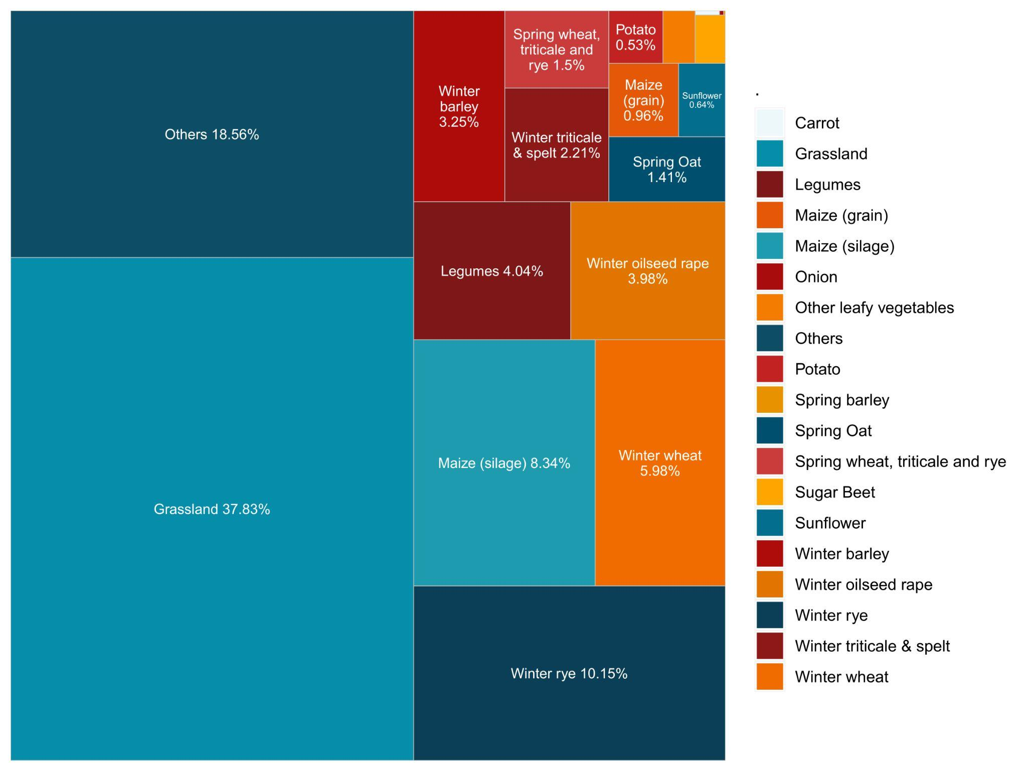

**Figure S1.** Distribution of crop types per field between 2011-2020 based on IACS. All fields with no data entries were removed before calculating proportions.

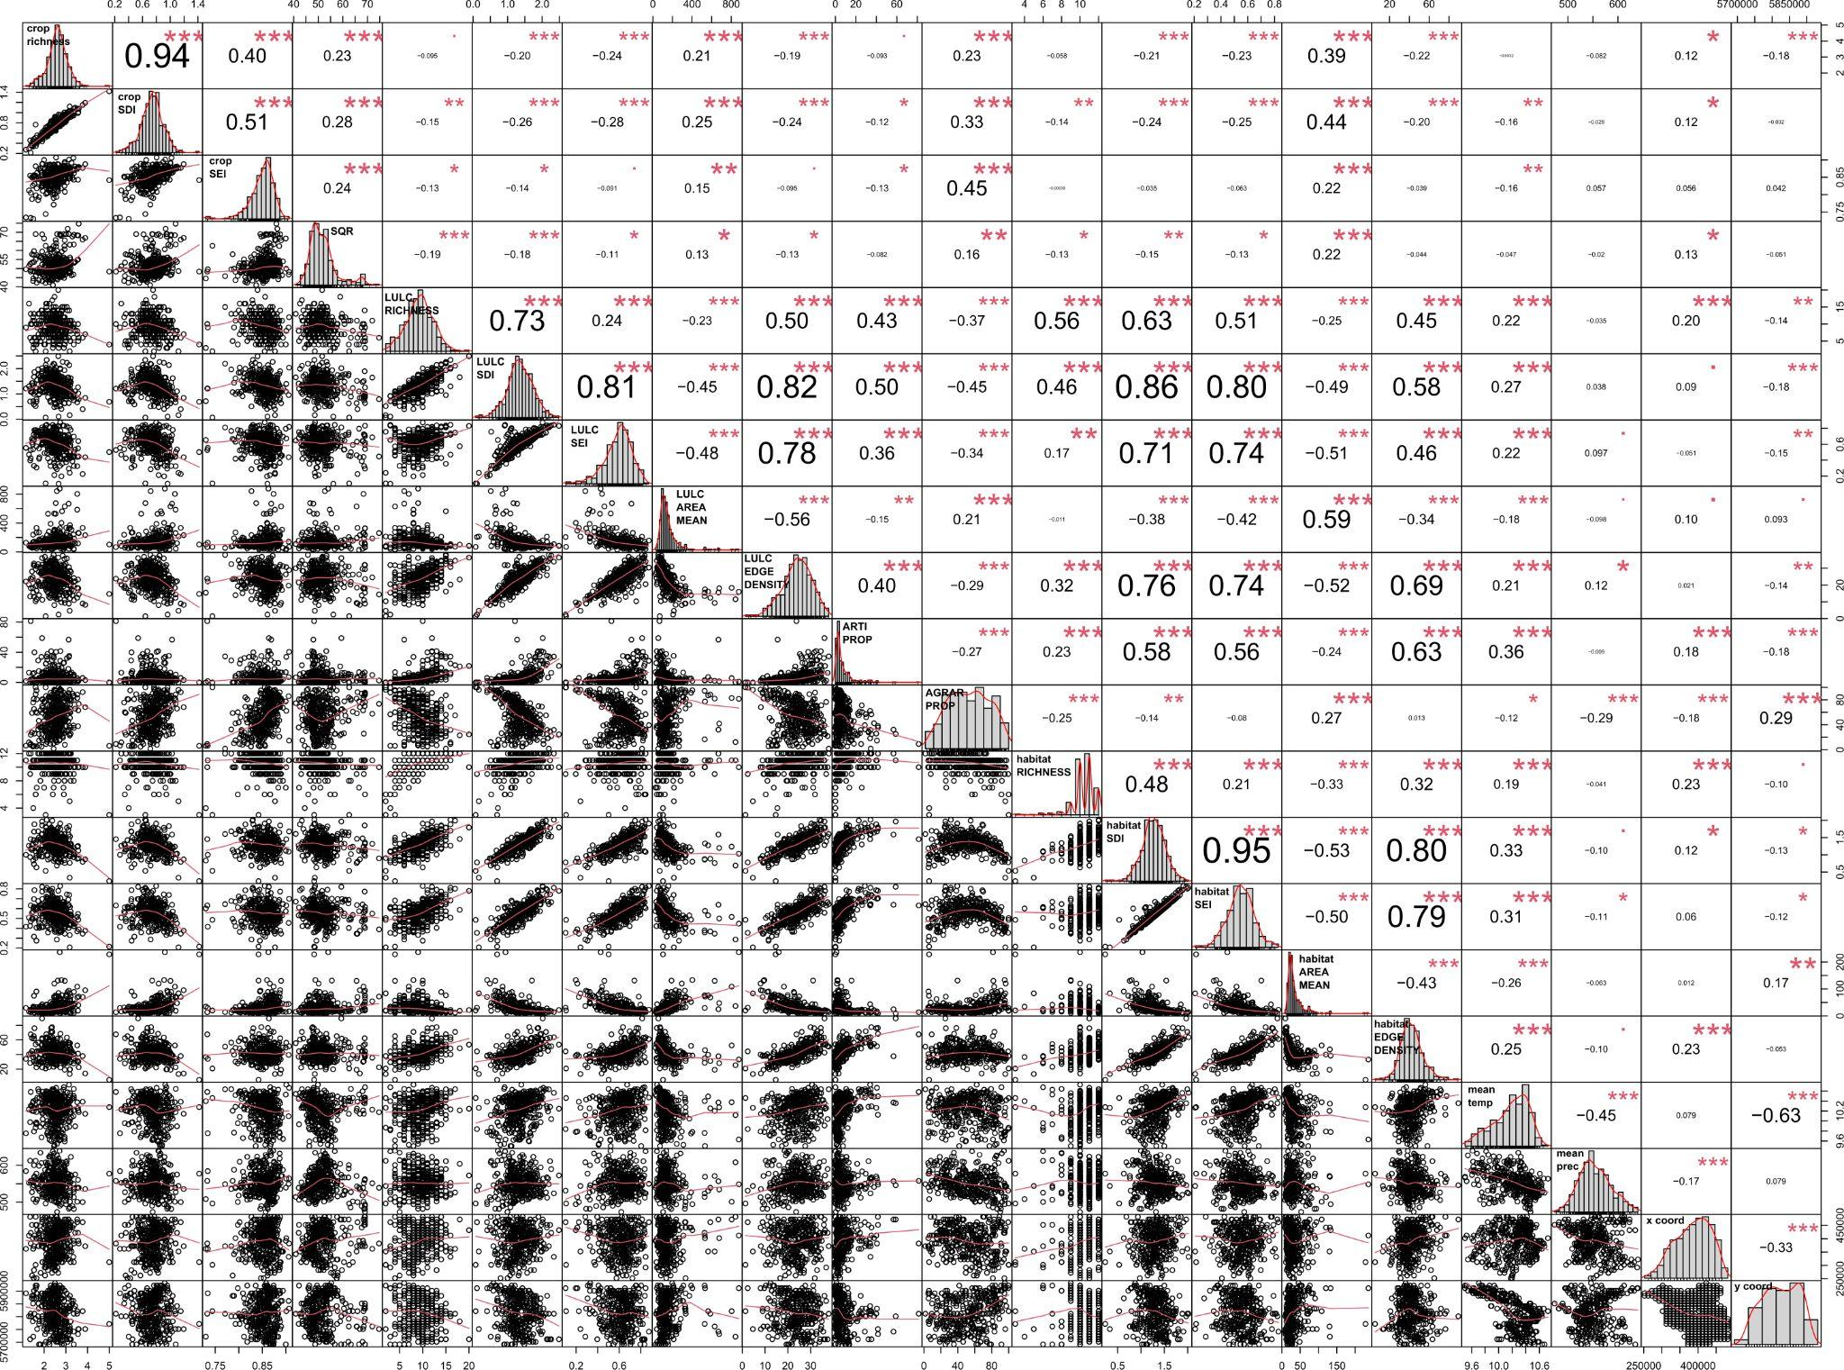

**Figure S2.** Correlation Matrix showing Pearson’s correlation; crop rotational richness, crop rotational diversity measured in Shannon’s diversity (SDI), crop rotational diversity measured in Shannon’s evenness (SEI), soil quality (SQR), Land use land cover (LULC) richness, LULC diversity measured in Shannon’s diversity (SDI), LULC diversity measured in Shannon’s evenness (SEI), LULC patch mean size (LULC area mean), LULC edge density, proportion of artificial surfaces (Arti Prop), proportion of agricultural area (Agrar Prop), habitat richness, habitat diversity measured in Shannon’s diversity (SDI), habitat diversity measured in Shannon’s evenness (SEI), habitat patch mean size (habitat area mean), H) habitat edge density, annual mean temperature (mean temp), annual mean precipitation sum (mean prec), y coordinate (y_coord), and x coordinate (x_coord).

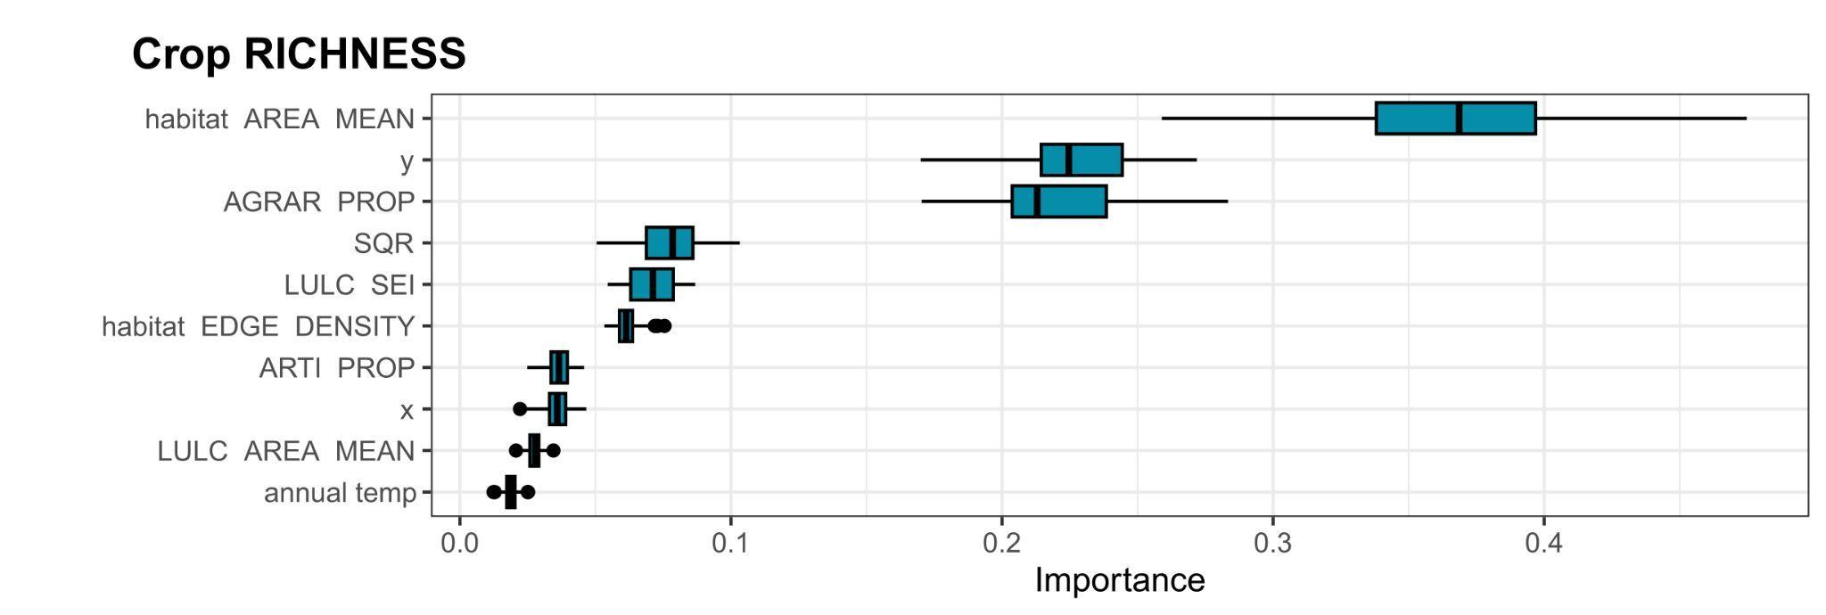

**Figure S3.** Modelled importance of variables for crop rotational richness in Brandenburg, Germany, using random forest machine learning models with permutation variable importance. Predictor variables are land use land cover (LULC) and habitat diversity indices (RICHNESS, Shannon’s diversity (SDI), and Shannon’s evenness (SEI), mean patch size (AREA MEAN), and patchiness (EDGE DENSITY)), proportion of agricultural area (AGRAR PROP), proportion of artificial surfaces (ARTI PROP), mean soil quality rating (SQR), mean annual temperature (annual temp), mean annual precipitation sum (annual prec), and x and y and coordinates (y, x). The boxplot includes the median as a thick black line within the coloured body that represents the distribution between the first and third quartiles. Whiskers show the distribution of the highest and lowest non-outlier values.

**Fig S4.** Modelled relationships among crop rotational richness and A) soil quality (SQR); B) annual mean temperature (mean temp); C) annual mean precipitation sum (mean prec); D) habitat richness; E) habitat diversity measured in Shannon’s diversity (SDI); F) habitat diversity measured in Shannon’s evenness (SEI); G) habitat patch mean size; H) habitat edge density (habitat_ED); I) Land use land cover (LULC) richness; J) LULC diversity measured in Shannon’s diversity (SDI); K) LULC diversity measured in Shannon’s evenness (SEI); L) LULC patch mean size; M) LULC edge density (LULC_ED); N) proportion of artificial surfaces (Arti Prop); O) proportion of agricultural area (Agrar Prop) using random forest machine learning models with partial dependence plot. a-o) show corresponding histograms.

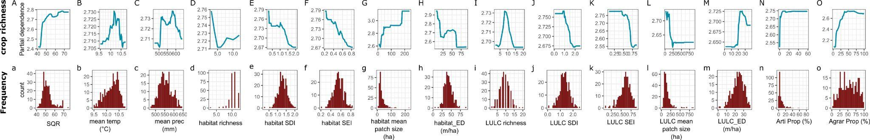

**Fig S5.** Modelled relationships among crop rotational diversity measured in Shannon’s diversity (SDI) and Shannon’s evenness (SEI) and annual mean temperature (mean temp), annual mean precipitation sum (mean prec), habitat richness; habitat diversity measured in Shannon’s diversity (SDI), habitat diversity measured in Shannon’s evenness (SEI), habitat edge density (habitat_ED), land use land cover (LULC) richness, LULC patch mean size, LULC edge density (LULC_ED), and proportion of artificial surfaces (Arti Prop) using random forest machine learning models with partial dependence plot. a-j) show corresponding histograms.

