# Appendix: Supplementary materials

Table of Contents

1 Methodological specifications 2

1.1 Calculation of the standardized precipitation evapotranspiration indices 2

1.2 Studied street tree species 3

1.3 Rationale for the selection of the time series processing tool 3

1.4 Visual explanation of the developed drought response metrics 4

2 Remarks on results and discussion 6

2.1 Correlation coefficients of vegetation indices by tree species 6

2.2 Time-lag analysis 7

2.3 Percentage of significant positive correlations 9

2.4 Changes in land cover and land use as an uncertainty factor 10

2.5 Spatial patterns of drought response exemplified by *T. cordata* trees 11

References Appendix 12

1. Methodological specifications
   1. Calculation of the standardized precipitation evapotranspiration indices

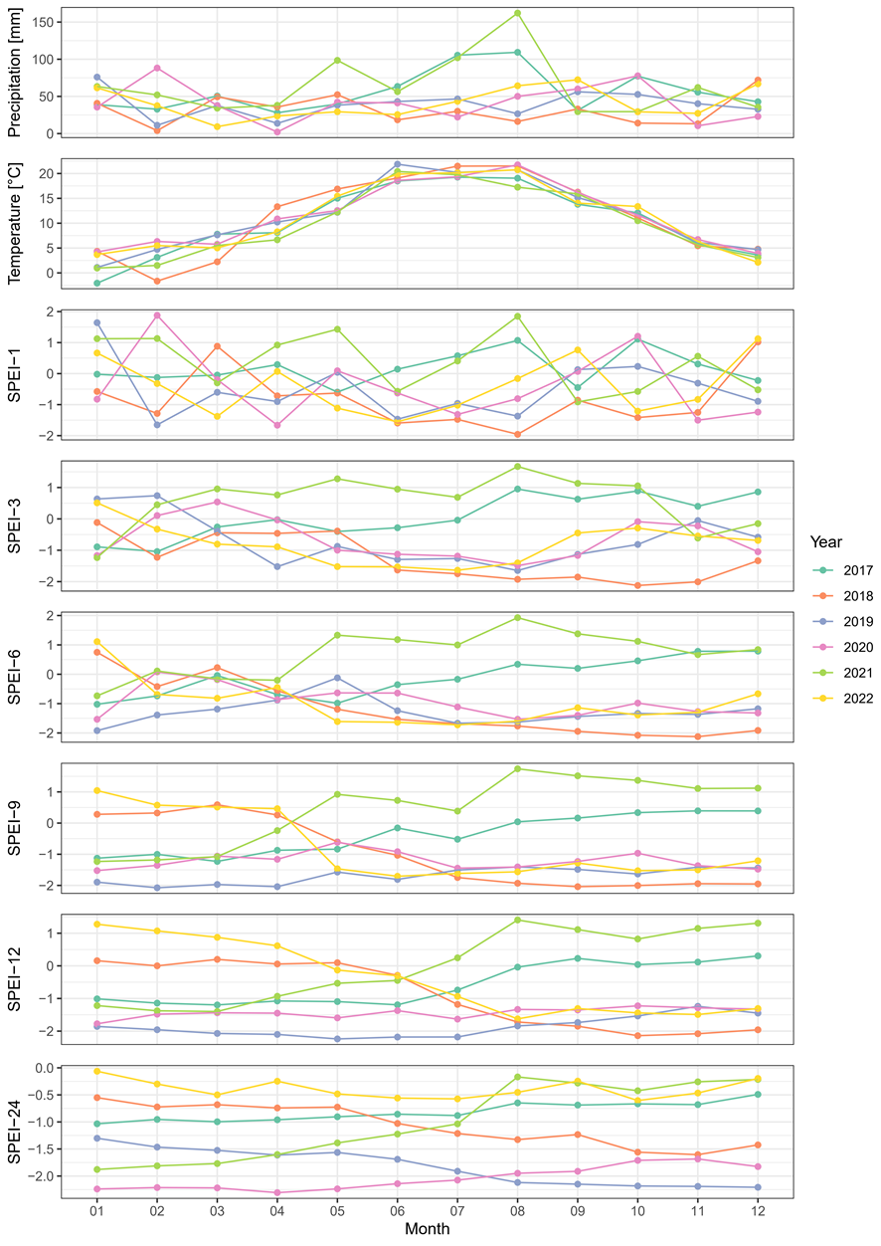

**Figure S1**: Precipitation, temperature, and standardized precipitation evapotranspiration index (SPEI) time series from 2017 to 2022.

SPEI-1, SPEI-3, SPEI-6, SPEI-9, SPEI-12, and SPEI-24 represent the SPEI based on accumulation periods of 1, 3, 6, 9, 12, and 24 months, respectively.

* 1. Studied street tree species

Ein Bild, das draußen, Text, Auto, Pflanze enthält.
Ein Bild, das draußen, Pflanze, Baum, Landfahrzeug enthält.
Ein Bild, das draußen, Pflanze, Baum, Landfahrzeug enthält.
Ein Bild, das draußen, Pflanze, Baum, Auto enthält.
Ein Bild, das draußen, Baum, Pflanze, Auto enthält.
Ein Bild, das Pflanze, draußen, Baum, Auto enthält.
Ein Bild, das Pflanze, draußen, Baum, Auto enthält.

**Figure S2**: Exemplary photos of the studied tree species. A) *Acer platanoides*, B) *Acer pseudoplatanus*, C) *Aesculus hippocastanum*, D) *Fraxinus excelsior*, E) *Platanus x acerifolia*, F*) Quercus robur*, G) *Tilia cordata*. Photos: Leonie Leisenheimer

* 1. Rationale for the selection of the time series processing tool

We use the processing software FORCE because it improves the cloud detection by the Fmask algorithm through the implementation of the cloud displacement index which uses the different viewing angles of the near infrared bands to distinguish elevated clouds from bright ground objects (Frantz, 2019; Frantz et al., 2018). In this way, FORCE compensates for the missing thermal band which usually hampers cloud detection, especially in urban areas where bright built-up surfaces are often misclassified as clouds (Frantz et al., 2018; Skakun et al., 2022). Frantz et al. (2018) successfully test the algorithm in metropolitan areas around the globe with an improvement of overall accuracy in cloud detection of 29-39 %. FORCE strives for aggressive cloud masking that increases producer’s accuracy making the dataset very suitable for time series analysis (Skakun et al., 2022).

A second essential feature of FORCE is the geometric co-registration of Sentinel-2 imagery based on Landsat imagery. Before March 2021, Sentinel-2 imagery had a multi-temporal accuracy of 12 m, i.e., exceeding one pixel, which impedes time series analysis in heterogeneous landscapes such as urban areas. The co-registration technique reduced the noise in time series by 43 % on average (Rufin et al., 2020).

* 1. Visual explanation of the developed drought response metrics

The following figures show the determination of the drought response metrics using an exemplary tree. The tree of species *A. platanoides* was planted in 1980. It is located in front of the school “Robert-Blum-Schule” and has a crown diameter of around 10 metres.

Notably, there is a lower data availability in the years 2017 and 2021 due to higher cloud cover (**Figure S3**). This also leads to missing values in the monthly aggregated time series (**Figure S4**) so that only 16 – instead of potentially 18 – median values can be used for the correlation between NBR-20 and SPEI-6 (**Figure S5**). In this example, the correlation coefficient of 0.85 is very high at a significance level of 0.01.

In contrast, the interpolated and smoothed time series fills the data gaps (**Figure S6**). The growing season integrals for the years 2017, 2018, 2019, 2020, 2021, and 2022 amount 65.1, 58.2, 60.4, 58.6, 68.5, and 60.3, respectively. Thus, the deviation integral between the years 2017 and 2018 is 6.9 with a maximum daily deviation of 0.1 on the 225th day of the year (**Figure S7**).

Ein Bild, das Text, Screenshot, Reihe, Diagramm enthält.

**Figure S3**: Example of a time series of the normalized burn ratio using the 20-metre resolution band (NBR-20) derived from bottom-of-atmosphere reflectance imagery.

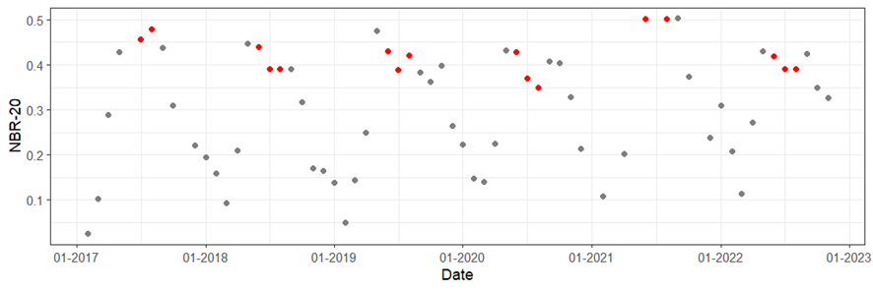

**Figure S4**: Example of a monthly median time series of the normalized burn ratio using the 20-metre resolution band (NBR-20), with median values used for correlation (i.e., June, July, and August) in red.

Ein Bild, das Reihe, Text, Diagramm, Zahl enthält.

**Figure S5**: Example of a Pearson’s correlation between the standardized precipitation evapotranspiration index with an accumulation period of six months (SPEI-6) and the monthly median of the normalized burn ratio using the 20-metre resolution band (NBR‑20) in the months June, July, and August.

Ein Bild, das Diagramm, Reihe, Screenshot, Text enthält.

**Figure S6**: Example of a time series of the normalized burn ratio using the 20-metre resolution band (NBR-20) processed by FORCE with an interpolation time step of 16 days in red and a linear daily interpolation in black. The grey dashed lines mark the start and end of the season. The grey areas represent the annual growing season integrals.

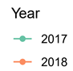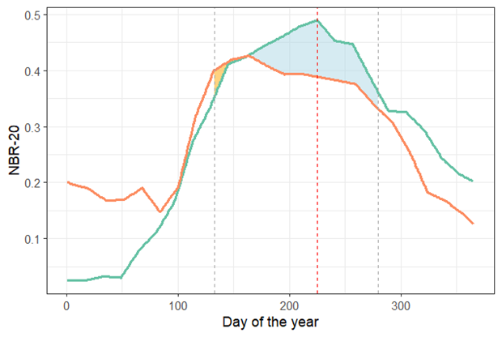

**Figure S7**: Example of a deviation between the growing season integrals of the years 2017 (turquoise line) and 2018 (orange line) derived from the time series of the normalized burn ratio using the 20-metre resolution band (NBR-20). The yellow area represents the negative deviations and the light-blue area the positive deviations. The grey dashed lines mark the start and end of the season. The red dashed line marks the maximum deviation date.

1. Remarks on results and discussion
   1. Correlation coefficients of vegetation indices by tree species

**Figure S8** differentiates the correlation coefficients of the correlation between six SPEI periods and eight vegetation indices by vegetation index and tree species. It reveals that *P. x acerifolia* exhibits the smallest correlation coefficients using all vegetation indices, whereas *Q. robur* exhibits the highest. Thus, the vegetation indices consistently determine differences in tree species. For most tree species, correlation coefficients based on NBR-20 are highest, except for *T. cordata*, where NDVI-20 achieves higher correlation coefficients, and *P. x acerifolia*, where RENDVI achieves slightly higher correlation coefficients than NBR-20.

Ein Bild, das Text, Screenshot, Diagramm enthält.

**Figure S8**: Correlation between eight monthly median vegetation indices (for abbreviations see **Table 2**) and standardized precipitation evapotranspiration indices by tree species and vegetation index.

* 1. Time-lag analysis

The correlation between the SPEIs and vegetation indices can reveal not only cumulative but also time-lagged drought effects. We repeat the correlation analysis for time lags of one month and two months by correlating the vegetation indices of June, July, and August with SPEIs of May, June, and July and April, May, and June, respectively. Overall, the results indicate slightly higher correlation coefficients with a time lag of one month and slightly lower correlation coefficients with a time lag of two months than without a time lag (**Figure S9** and **Figure S10**). The species-specific patterns are similar in that *P. x acerifolia* shows lower correlation coefficients than the other species and *T. cordata* a high dispersion of correlation coefficients. The difference is that the correlation coefficients with SPEI-1 increase, whereas the correlation coefficients with SPEI-12 decrease for all species except *P. x acerifolia* when applying time lags. Thus, the response of street trees to drought is not time-lagged per se but the time-lag depends on the duration of the drought and the tree species. Similarly, Gessner et al. (2013) do not find clear time-lagged drought response patterns in deciduous trees. Most other studies refer to grasslands and reveal time lags of one to three months (Gessner et al., 2013). As such, correlation coefficients are valuable in enhancing the understanding of responses of different street tree species to the various temporal scales of droughts.

Ein Bild, das Text, Diagramm, Screenshot, parallel enthält.

**Figure S9**: Correlation between the monthly median normalized burn ratio using the 20-metre resolution band and the standardized precipitation evapotranspiration index (SPEI) with a time lag of one month by tree species and SPEI period.

SPEI-1, SPEI-3, SPEI-6, SPEI-9, SPEI-12, and SPEI-24 are based on accumulation periods of 1, 3, 6, 9, 12, and 24 months, respectively.

Ein Bild, das Text, Screenshot, Diagramm, parallel enthält.

**Figure S10**: Correlation between the monthly median normalized burn ratio using the 20-metre resolution band and the standardized precipitation evapotranspiration index (SPEI) with a time lag of two months by tree species and SPEI period.

SPEI-1, SPEI-3, SPEI-6, SPEI-9, SPEI-12, and SPEI-24 are based on accumulation periods of 1, 3, 6, 9, 12, and 24 months, respectively.

* 1. Percentage of significant positive correlations

**Table S1** summarizes the percentage of significant positive correlations between the SPEIs and vegetation indices. The percentages confirm the observations from the boxplots **(Figure 4**). *Q. robur* has the highest percentage of significant positive correlations with 69% for the correlation between NBR-20 and SPEI-9, while *P. x acerifolia* has the lowest percentage of significant positive correlations with 17% for the correlation between SPEI-24 and RENDVI. This underlines the delayed response of *P. x acerifolia* to drought. For all species except *T. cordata* and *P. x acerifolia* NBR is the vegetation index with the highest percentage of positive correlations. For *T. cordata*, RGVI, and for *P. x acerifolia* RENDVI seem to be more suited.

**Table S1**: Percentage of significant positive correlations per tree species.

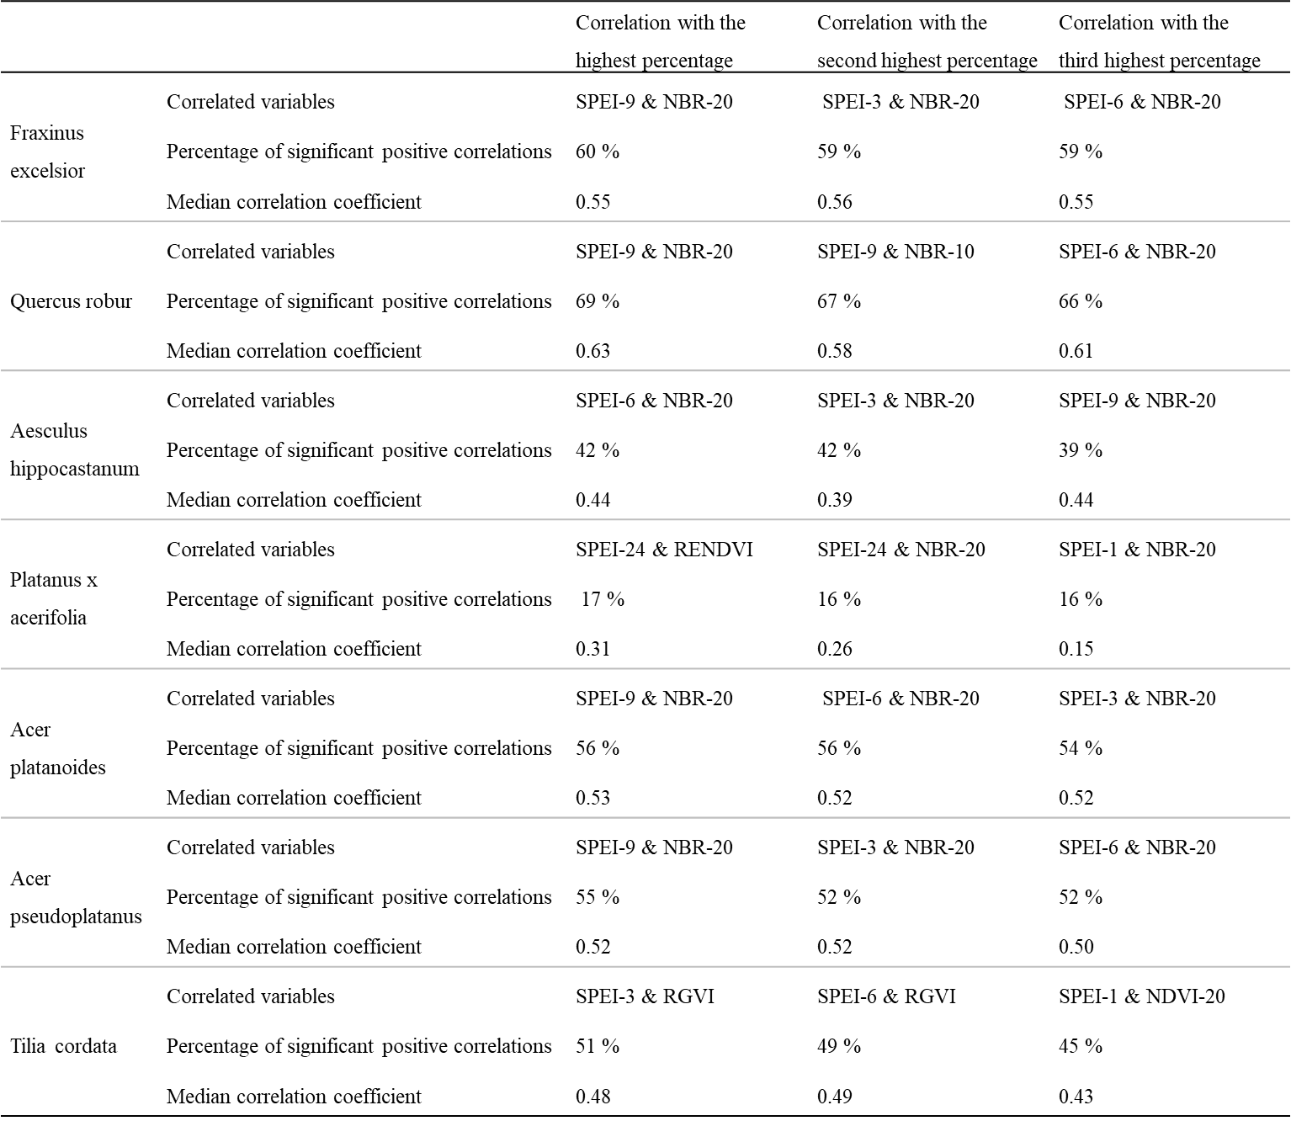

SPEI-1, SPEI-3, SPEI-6, SPEI-9, SPEI-12, and SPEI-24 represent the standardized precipitation evapotranspiration indices (SPEI) based on accumulation periods of 1, 3, 6, 9, 12, and 24 months, respectively.

For abbreviations of vegetation indices NBR-20, NBR-10, NDVI-20, RENDVI, and RGVI, see **Table 2**.

* 1. Changes in land cover and land use as an uncertainty factor

In Section 4.2.1, we discuss how land use and land cover in the surroundings of street trees affect the drought response metrics. The following figures (**Figure S11** and **Figure S12**) show a new construction site associated with tree felling next to a *P. x acerifolia* tree in the sample. This land cover change causes the sudden decline in the NBR-20 time series of this tree (**Figure 7**). Consequently, the drought response metrics incorrectly indicate strong drought response in this case for *P. x acerifolia* since the change in NBR-20 is unrelated to drought.

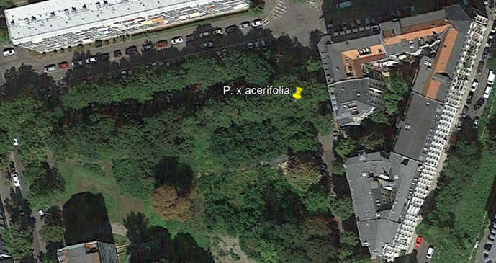

**Figure S11**: Aerial photo of the surroundings of *P. x acerifolia* (yellow pin) in 08/2017 (Google, 2023).

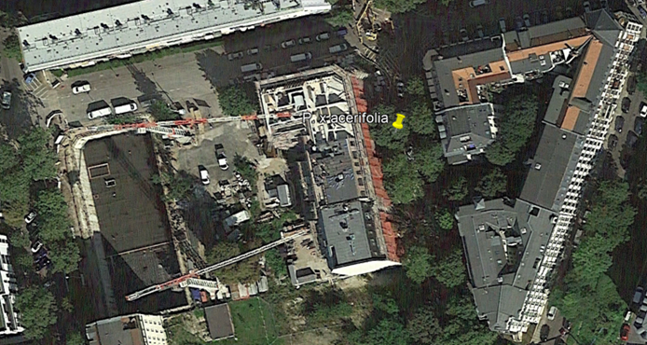

**Figure S12**: Aerial photo of the surroundings of *P. x acerifolia* (yellow pin) in 09/2021 (Google, 2023).

* 1. Spatial patterns of drought response exemplified by *T. cordata* trees

The discussion on the drought response variability within tree species implies a high influence of site characteristics on street tree response to drought. **Figure S13** exemplifies the spatial distribution of drought responses of *T. cordata* trees. Both drought response metrics consistently indicate that the tree alignment in the northwest of Leipzig responds strongly to drought, while there are several individual trees and tree alignments in the centre that are not strongly affected.

These site-specific characteristics suggest a closer look at tree conditions in the city of Leipzig. The strongly drought-affected tree alignment of *T. cordata* in the northwest of Leipzig is located in the floodplain landscape between the rivers “Weiße Elster” and “Neue Luppe”. This is surprising because in this area one might suspect good access of trees to groundwater sources. However, due to land use changes, groundwater levels are sinking which is why the sensitivity of trees to drought is rising and tipping points of these ecosystems might be reached (Schnabel et al., 2022). Schnabel et al. (2022) find trees in floodplain areas to be particularly affected by prolonged droughts. While trees in their study are more responsive to the drought in 2019 than in 2018, it is reversed in this study. Possibly, drought effects in floodplain forests, as in the study by Schnabel et al. (2022), are buffered more by groundwater reserves than in street trees, as in this study, where anthropogenic soils have replaced natural floodplain soils (Bräunig, 2020; Wirth et al., 2021).

However, it might also be that the tree alignment is incorrectly indicated as highly drought responsive due to a methodological limitation. The trees are surrounded by agricultural land which might undergo different management practices and responds to drought in a different manner than trees (Zhou et al., 2022). Consequently, the implied strong drought response might actually be caused by the surrounding agricultural land rather than solely by the street trees.

The example demonstrates, first, the potential for further spatial analysis of various street tree responses to drought, and second, the need to validate the drought response metrics through field observations.

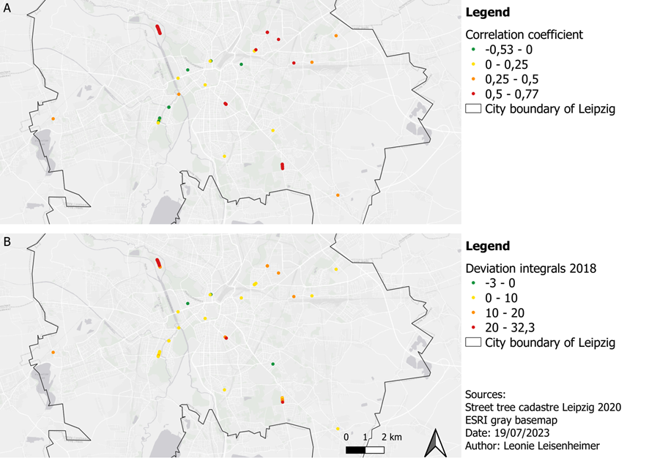

**Figure S13**: Spatial distribution of *Tilia cordata* responses to drought based on correlation analysis (A) and land surface phenology analysis (B).

References Appendix

Bräunig, A. (2020). *Bodenkarte 1 : 50.000 (BK50)*. https://luis.sachsen.de/fachbereich-boden-bodenkarte-bk50.html (Accessed 2023-07-23).

Frantz, D. (2019). FORCE – Landsat + Sentinel-2 analysis ready data and beyond. *Remote Sensing*, *11*(9), 1124. https://doi.org/10.3390/rs11091124

Frantz, D., Haß, E., Uhl, A., Stoffels, J., & Hill, J. (2018). Improvement of the Fmask algorithm for Sentinel-2 images: Separating clouds from bright surfaces based on parallax effects. *Remote Sensing of Environment*, *215*, 471–481. https://doi.org/10.1016/j.rse.2018.04.046

Gessner, U., Naeimi, V., Klein, I., Kuenzer, C., Klein, D., & Dech, S. (2013). The relationship between precipitation anomalies and satellite-derived vegetation activity in Central Asia. *Global and Planetary Change*, *110*, 74–87. https://doi.org/10.1016/j.gloplacha.2012.09.007

Google. (2023). *Google Earth Pro* (Version 7.3) [Computer software]. https://www.google.com/earth/about/versions/

Rufin, P., Frantz, D., Yan, L., & Hostert, P. (2020). Operational coregistration of the Sentinel-2A/B image archive using multitemporal Landsat spectral averages. *IEEE Geoscience and Remote Sensing Letters*, *18*(4), 712–716. https://doi.org/10.1109/LGRS.2020.2982245

Schnabel, F., Purrucker, S., Schmitt, L., Engelmann, R. A., Kahl, A., Richter, R [Ronny], Seele-Dilbat, C., Skiadaresis, G., & Wirth, C. (2022). Cumulative growth and stress responses to the 2018-2019 drought in a European floodplain forest. *Global Change Biology*, *28*(5), 1870–1883. https://doi.org/10.1111/gcb.16028

Skakun, S., Wevers, J., Brockmann, C., Doxani, G., Aleksandrov, M., Batič, M., Frantz, D., Gascon, F., Gómez-Chova, L., Hagolle, O., López-Puigdollers, D., Louis, J., Lubej, M., Mateo-García, G., Osman, J., Peressutti, D., Pflug, B., Puc, J., Richter, R [Rudolf], . . . Žust, L. (2022). Cloud Mask Intercomparison eXercise (CMIX): An evaluation of cloud masking algorithms for Landsat 8 and Sentinel-2. *Remote Sensing of Environment*, *274*, 112990. https://doi.org/10.1016/j.rse.2022.112990

Wirth, C., Engelmann, R. A., Haack, N., Hartmann, H., Richter, R [Ronny], Schnabel, F., Scholz, M., & Seele-Dilbat, C. (2021). Naturschutz und Klimawandel im Leipziger Auwald: Ein Biodiversitätshotspot an der Belastungsgrenze. *Biologie in unserer Zeit*, *51*(1), 55–65. https://doi.org/10.11576/BIUZ-4107

Zhou, R., Liu, Y., Cui, M., Lu, J., Shi, H., Ren, H., Zhang, W., & Wen, Z. (2022). Global assessment of cumulative and time-lag effects of drought on land surface phenology. *GIScience & Remote Sensing*, *59*(1), 1918–1937. https://doi.org/10.1080/15481603.2022.2143661